A
PROJECT REPORT ON
VOICE BASED CONTROL DEVICE USING
BLUETOOTH TECHNOLOGY
DIPLOMA
IN
ELECTRICAL AND ELECTRONICS ENGINEERING

SUBMITTED BY
A.VISHNU
PIN NO: 17004-EE-059

Under The Guidance of
Mr.Santhosh
LECTURER IN EEE DEPT.

DEPARTMENT OF ELECTRICAL AND ELECTRONICS ENGINEERING,
GOVT. POLYTECHNIC WARANGAL
HYDERABAD – 506006
2017-2020

STATE BOARD OF TECHNICAL EDUCATION AND TRAINING
DEPARTMENT OF ELECTRICAL AND ELECTRONICS ENGINEERING
BATCH CERTIFICATE
This Is To Certify That The Project Work Entitle, “VOICE BASED CONTROL DEVICE USING BLUETOOTH TECHNOLOGY”.Have Been Successfully Completed In The Partial Fulfillment For The Award Of Degree In Diploma In Electrical &Electronic Engineering During the Academic Years 2017-2020 By the Following Students
NAME | PIN NO
A VISHNU | 17004-EE-059
SK MOIN SADIQ | 17004-EE-037
P HARSHITHA | 17004-EE-038
J SHEKAR | 17004-EE-049
B RENU GAYATHRI | 17004-EE-057


Mr. Santhosh Mrs. P Sridevi
Internal Guide Head Of EEE Dept.,

Mr. S M PRASAD
Principal

ACKNOWLEDGEMENT

The satisfaction of this project completion would be incomplete, without thanking all the members who helped to do this project in one or the other way.
Firstly, I thank our principal Mr.Prabhakar for his great encouragement for doing this project with a successful completion.
I sincerely thank Mrs. P Sridevi Head of ELECTRICAL Department for her love, affection and kind cooperation in doing this project.
I express my heartily gratitude to Mrs.Santhosh Lecturer in ELECTRICAL engineering, for his great advice, motive spirit and with great inspiration until the end of the project.
I also thank all the staff of the ELECTRICAL department for having enthusiasm for the project.
Finally I thank all my team members for doing extraordinary work in successful completion of this project.

ABSTRACT

The aim of this project is to provide an efficient solution for control of electrical loads by voice using Bluetooth technology. Now a day’s technology is running with time, it completely occupied the life style of human beings. Even though there is such an importance for technology in our routine life there are even people whose life styles are very far to this well known term technology. So it is our responsibility to design few reliable systems which can be even efficiently used by them. This basic idea gave birth to the project control systems by voice command. Here the process is done through the micro controller and Bluetooth based technology.

INDEX

TOPICS

- Certificates.
- Acknowledgement.
CHAPTER 1: INTRODUCTION

  - Introduction of the project .
  - Project overview.
  - Thesis.

CHAPTER 2: EMBEDDED SYSTEMS

2.1 Introduction to embedded systems
2.2 Need of embedded systems
2.3 Explanation of embedded systems
2.4 Applications of embedded systems

CHAPTER 3: HARDWARE DESCRIPTION

3.1 Introduction with block diagram
3.2 Microcontroller
3.3Bluetooth module
3.6 Relay
3.7 DC motor
3.8 led indicator

4.1 Express PCB
4.2 ARDUINO Compiler
4.3 Proteus software
4.4 Procedural steps for compilation, simulation and dumping
CHAPTER 5: PROJECT DESCRIPTION

CHAPTER 6: ADVANTAGES, DISADVANTAGES AND APPLICATIONS

CHAPTER 7: RESULTS, CONCLUSION, FUTURE PROSPECTS

REFERENCES

Introduction :
Function Requirements:
- Working voltage: Positive 6-12v DC (for kit).
- Motor voltage: 8-40v DC.
- Maximum current: 100mA for circuit,
- Up to 6A for motor.
- Stepper motors are not just rated by voltage.
Hardware required
- Power supply
- Arduino Nano Microcontroller
- Bluetooth module
- Motor Driver with DC Motor
- Buzzer
- Relay
- LED Indicators.

Software Required
- Arduino IDE -for code compilation & Dumping software.
- Language: Embedded C for hardware code
- Express PCB software for schematic design.
1.2 Project Overview:
An embedded system is a combination of software and hardware to perform a dedicated task. Some of the main devices used in embedded products are Microprocessors and Microcontrollers.
Microprocessors are commonly referred to as general purpose processors as they simply accept the inputs, process it and give the output. In contrast, a microcontroller not only accepts the data as inputs but also manipulates it, interfaces the data with various devices, controls the data and thus finally gives the result.
The project “VOICE CONTROLLED DEVICE USING BLUETOOTH” microcontroller is an exclusive project which is used to design an automated system which is capable of automatically controlling the toll gate accessing system based on RFID reader authentication.
1.3 Thesis:
The thesis explains the implementation of “” using ARDUINO microcontroller. The organization of the thesis is explained here with:
Chapter 1 Presents introduction to the overall thesis and the overview of the project. In the project overview, a brief introduction of wireless metal detector robot and its applications are discussed.
Chapter 2 Presents the topic embedded systems. It explains the about what is embedded systems, need for embedded systems, explanation of it along with its applications.
Chapter 3 Presents the hardware description. It deals with the block diagram of the project and explains the purpose of each block. In the same chapter the explanation of microcontroller,
GPRS WIFI module, power supplies, LCD, DC motor, buzzer are considered.
Chapter 4 Presents the software description. It explains the implementation of the project using ARDUINO C Compiler software.
Chapter 5 Presents the project description along with Bluetooth module, DC motor interfacing to microcontroller.
Chapter 6 Presents the results, conclusion and future scope of the project.

CHAPTER 2: EMBEDDED SYSTEMS
2.1 Embedded Systems:
An embedded system is a computer system designed to perform one or a few dedicated functions often with real-time computing constraints. It is embedded as part of a complete device often including hardware and mechanical parts. By contrast, a general-purpose computer, such as a personal computer (PC), is designed to be flexible and to meet a wide range of end-user needs. Embedded systems control many devices in common use today.
Embedded systems are controlled by one or more main processing cores that are typically either microcontrollers or digital signal processors (DSP). The key characteristic, however, is being dedicated to handle a particular task, which may require very powerful processors. For example, air traffic control systems may usefully be viewed as embedded, even though they involve mainframe computers and dedicated regional and national networks between airports and radar sites. (Each radar probably includes one or more embedded systems of its own.)
Since the embedded system is dedicated to specific tasks, design engineers can optimize it to reduce the size and cost of the product and increase the reliability and performance. Some embedded systems are mass-produced, benefiting from economies of scale.
Physically embedded systems range from portable devices such as digital watches and MP3 players, to large stationary installations like traffic lights, factory controllers, or the systems controlling nuclear power plants. Complexity varies from low, with a single microcontroller chip, to svery high with multiple units, peripherals and networks mounted inside a large chassis or enclosure.
In general, "embedded system" is not a strictly definable term, as most systems have some element of extensibility or programmability. For example, handheld computers share some elements with embedded systems such as the operating systems and microprocessors which power them, but they allow different applications to be loaded and peripherals to be connected. Moreover, even systems which don't expose programmability as a primary feature generally need to support software updates. On a continuum from "general purpose" to "embedded", large application systems will have subcomponents at most points even if the system as a whole is "designed to perform one or a few dedicated functions", and is thus appropriate to call "embedded". A modern example of embedded system is shown in fig: 2.1.
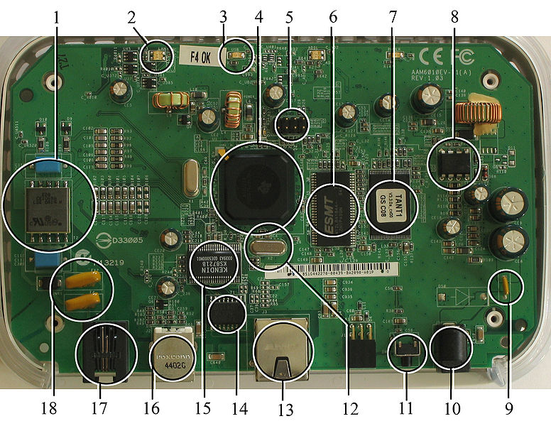
Fig 2.1:A modern example of embedded system
Labeled parts include microprocessor (4), RAM (6), flash memory (7).Embedded systems programming is not like normal PC programming. In many ways, programming for an embedded system is like programming PC 15 years ago. The hardware for the system is usually chosen to make the device as cheap as possible. Spending an extra dollar a unit in order to make things easier to program can cost millions. Hiring a programmer for an extra month is cheap in comparison. This means the programmer must make do with slow processors and low memory, while at the same time battling a need for efficiency not seen in most PC applications. Below is a list of issues specific to the embedded field.
2.1.1 History:
In the earliest years of computers in the 1930–40s, computers were sometimes dedicated to a single task, but were far too large and expensive for most kinds of tasks performed by embedded computers of today. Over time however, the concept of programmable controllers evolved from traditional electromechanical sequencers, via solid state devices, to the use of computer technology.
One of the first recognizably modern embedded systems was the Apollo Guidance Computer, developed by Charles Stark Draper at the MIT Instrumentation Laboratory. At the project's inception, the Apollo guidance computer was considered the riskiest item in the Apollo project as it employed the then newly developed monolithic integrated circuits to reduce the size and weight. An early mass-produced embedded system was the Autonetics D-17 guidance computer for the Minuteman missile, released in 1961. It was built from transistor logic and had a hard disk for main memory. When the Minuteman II went into production in 1966, the D-17 was replaced with a new computer that was the first high-volume use of integrated circuits.
2.1.2 Tools:
Embedded development makes up a small fraction of total programming. There's also a large number of embedded architectures, unlike the PC world where 1 instruction set rules, and the UNIX world where there's only 3 or 4 major ones. This means that the tools are more expensive. It also means that they're lowering featured, and less developed. On a major embedded project, at some point you will almost always find a compiler bug of some sort.
Debugging tools are another issue. Since you can't always run general programs on your embedded processor, you can't always run a debugger on it. This makes fixing your program difficult. Special hardware such as JTAG ports can overcome this issue in part. However, if you stop on a breakpoint when your system is controlling real world hardware (such as a motor), permanent equipment damage can occur. As a result, people doing embedded programming quickly become masters at using serial IO channels and error message style debugging.
2.1.3 Resources:
To save costs, embedded systems frequently have the cheapest processors that can do the job. This means your programs need to be written as efficiently as possible. When dealing with large data sets, issues like memory cache misses that never matter in PC programming can hurt you. Luckily, this won't happen too often- use reasonably efficient algorithms to start, and optimize only when necessary. Of course, normal profilers won't work well, due to the same reason debuggers don't work well.
Memory is also an issue. For the same cost savings reasons, embedded systems usually have the least memory they can get away with. That means their algorithms must be memory efficient (unlike in PC programs, you will frequently sacrifice processor time for memory, rather than the reverse). It also means you can't afford to leak memory. Embedded applications generally use deterministic memory techniques and avoid the default "new" and "malloc" functions, so that leaks can be found and eliminated more easily. Other resources programmers expect may not even exist. For example, most embedded processors do not have hardware FPUs (Floating-Point Processing Unit). These resources either need to be emulated in software, or avoided altogether.

2.1.4 Real Time Issues:
Embedded systems frequently control hardware, and must be able to respond to them in real time. Failure to do so could cause inaccuracy in measurements, or even damage hardware such as motors. This is made even more difficult by the lack of resources available. Almost all embedded systems need to be able to prioritize some tasks over others, and to be able to put off/skip low priority tasks such as UI in favor of high priority tasks like hardware control.
2.2 Need For Embedded Systems:
The uses of embedded systems are virtually limitless, because every day new products are introduced to the market that utilizes embedded computers in novel ways. In recent years, hardware such as microprocessors, microcontrollers, and FPGA chips have become much cheaper. So when implementing a new form of control, it's wiser to just buy the generic chip and write your own custom software for it. Producing a custom-made chip to handle a particular task or set of tasks costs far more time and money. Many embedded computers even come with extensive libraries, so that "writing your own software" becomes a very trivial task indeed. From an implementation viewpoint, there is a major difference between a computer and an embedded system. Embedded systems are often required to provide Real-Time response. The main elements that make embedded systems unique are its reliability and ease in debugging.
2.2.1 Debugging:
Embedded debugging may be performed at different levels, depending on the facilities available. From simplest to most sophisticate they can be roughly grouped into the following areas:
- Interactive resident debugging, using the simple shell provided by the embedded operating system (e.g. Forth and Basic)
- External debugging using logging or serial port output to trace operation using either a monitor in flash or using a debug server like the Remedy Debugger which even works for heterogeneous multi core systems.
- An in-circuit debugger (ICD), a hardware device that connects to the microprocessor via a JTAG or Nexus interface. This allows the operation of the microprocessor to be controlled externally, but is typically restricted to specific debugging capabilities in the processor.
- An in-circuit emulator replaces the microprocessor with a simulated equivalent, providing full control over all aspects of the microprocessor.
- A complete emulator provides a simulation of all aspects of the hardware, allowing all of it to be controlled and modified and allowing debugging on a normal PC.
- Unless restricted to external debugging, the programmer can typically load and run software through the tools, view the code running in the processor, and start or stop its operation. The view of the code may be as assembly code or source-code.
Because an embedded system is often composed of a wide variety of elements, the debugging strategy may vary. For instance, debugging a software (and microprocessor) centric embedded system is different from debugging an embedded system where most of the processing is performed by peripherals (DSP, FPGA and co-processor). An increasing number of embedded systems today use more than one single processor core. A common problem with multi-core development is the proper synchronization of software execution. In such a case, the embedded system design may wish to check the data traffic on the busses between the processor cores, which requires very low-level debugging, at signal/bus level, with a logic analyzer, for instance.
2.2.2 Reliability:
Embedded systems often reside in machines that are expected to run continuously for years without errors and in some cases recover by them if an error occurs. Therefore the software is usually developed and tested more carefully than that for personal computers, and unreliable mechanical moving parts such as disk drives, switches or buttons are avoided.
Specific reliability issues may include:
- The system cannot safely be shut down for repair, or it is too inaccessible to repair. Examples include space systems, undersea cables, navigational beacons, bore-hole systems, and automobiles.
- The system must be kept running for safety reasons. "Limp modes" are less tolerable. Often backups are selected by an operator. Examples include aircraft navigation, reactor control systems, safety-critical chemical factory controls, train signals, engines on single-engine aircraft.
- The system will lose large amounts of money when shut down: Telephone switches, factory controls, bridge and elevator controls, funds transfer and market making, automated sales and service.
A variety of techniques are used, sometimes in combination, to recover from errors—both software bugs such as memory leaks, and also soft errors in the hardware:
- Watchdog timer that resets the computer unless the software periodically notifies the watchdog
- Subsystems with redundant spares that can be switched over to
- software "limp modes" that provide partial function
- Designing with a Trusted Computing Base (TCB) architecture[6] ensures a highly secure & reliable system environment
- An Embedded Hypervisor is able to provide secure encapsulation for any subsystem component, so that a compromised software component cannot interfere with other subsystems, or privileged-level system software. This encapsulation keeps faults from propagating from one subsystem to another, improving reliability. This may also allow a subsystem to be automatically shut down and restarted on fault detection.
- Immunity Aware Programming

2.3 Explanation of Embedded Systems:
2.3.1 Software Architecture:
There are several different types of software architecture in common use.
- Simple Control Loop:
In this design, the software simply has a loop. The loop calls subroutines, each of which manages a part of the hardware or software.
- Interrupt Controlled System:
Some embedded systems are predominantly interrupt controlled. This means that tasks performed by the system are triggered by different kinds of events. An interrupt could be generated for example by a timer in a predefined frequency, or by a serial port controller receiving a byte. These kinds of systems are used if event handlers need low latency and the event handlers are short and simple.
Usually these kinds of systems run a simple task in a main loop also, but this task is not very sensitive to unexpected delays. Sometimes the interrupt handler will add longer tasks to a queue structure. Later, after the interrupt handler has finished, these tasks are executed by the main loop. This method brings the system close to a multitasking kernel with discrete processes.
- Cooperative Multitasking:
A non-preemptive multitasking system is very similar to the simple control loop scheme, except that the loop is hidden in an API. The programmer defines a series of tasks, and each task gets its own environment to “run” in. When a task is idle, it calls an idle routine, usually called “pause”, “wait”, “yield”, “nop” (stands for no operation), etc.
The advantages and disadvantages are very similar to the control loop, except that adding new software is easier, by simply writing a new task, or adding to the queue-interpreter.
- Primitive Multitasking:
In this type of system, a low-level piece of code switches between tasks or threads based on a timer (connected to an interrupt). This is the level at which the system is generally considered to have an "operating system" kernel. Depending on how much functionality is required, it introduces more or less of the complexities of managing multiple tasks running conceptually in parallel.
As any code can potentially damage the data of another task (except in larger systems using an MMU) programs must be carefully designed and tested, and access to shared data must be controlled by some synchronization strategy, such as message queues, semaphores or a non-blocking synchronization scheme.
Because of these complexities, it is common for organizations to buy a real-time operating system, allowing the application programmers to concentrate on device functionality rather than operating system services, at least for large systems; smaller systems often cannot afford the overhead associated with a generic real time system, due to limitations regarding memory size, performance, and/or battery life.
- Microkernels And Exokernels:
A microkernel is a logical step up from a real-time OS. The usual arrangement is that the operating system kernel allocates memory and switches the CPU to different threads of execution. User mode processes implement major functions such as file systems, network interfaces, etc.
In general, micro kernels succeed when the task switching and inter task communication is fast, and fail when they are slow. Exokernels communicate efficiently by normal subroutine calls. The hardware and all the software in the system are available to, and extensible by application programmers. Based on performance, functionality, requirement the embedded systems are divided into three categories:
2.3.2 Stand Alone Embedded System:
These systems takes the input in the form of electrical signals from transducers or commands from human beings such as pressing of a button etc.., process them and produces desired output. This entire process of taking input, processing it and giving output is done in standalone mode. Such embedded systems comes under stand alone embedded systems
E.g.: microwave oven, air conditioner etc...
2.3.3 Real-time embedded systems:
Embedded systems which are used to perform a specific task or operation in a specific time period those systems are called as real-time embedded systems. There are two types of real-time embedded systems.
  - Hard Real-time embedded systems:
These embedded systems follow an absolute dead line time period i.e.., if the tasking is not done in a particular time period then there is a cause of damage to the entire equipment.
Eg: consider a system in which we have to open a valve within 30 milliseconds. If this valve is not opened in 30 ms this may cause damage to the entire equipment. So in such cases we use embedded systems for doing automatic operations.
- Soft Real Time embedded systems:
These embedded systems follow a relative dead line time period i.e.., if the task is not done in a particular time that will not cause damage to the equipment.
Eg: Consider a TV remote control system, if the remote control takes a few milliseconds delay it will not cause damage either to the TV or to the remote control. These systems which will not cause damage when they are not operated at considerable time period those systems comes under soft real-time embedded systems.
2.3.4 Network communication embedded systems:
A wide range network interfacing communication is provided by using embedded systems.
Eg:
- Consider a web camera that is connected to the computer with internet can be used to spread communication like sending pictures, images, videos etc.., to another computer with internet connection throughout anywhere in the world.
- Consider a web camera that is connected at the toll gate lock.
Whenever a person comes near the toll gate, it captures the image of a person and sends to the desktop of your computer which is connected to internet. This gives an alerting message with image on to the desktop of your computer, and then you can open the toll gate lock by clicking the mouse.

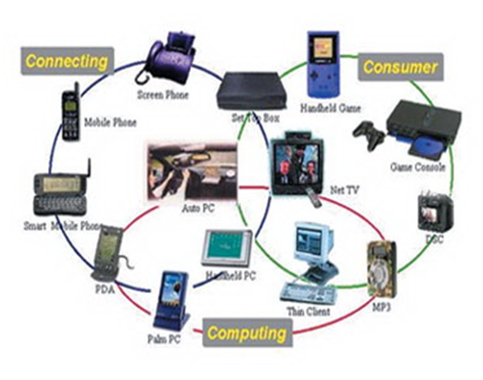
Fig 2.2: Network communication embedded systems

2.3.5 Different types of processing units:
The central processing unit (c.p.u) can be any one of the following microprocessor, microcontroller, digital signal processing.
- Among these Microcontroller is of low cost processor and one of the main advantage of microcontrollers is, the components such as memory, serial communication interfaces, analog to digital converters etc.., all these are built on a single chip. The numbers of external components that are connected to it are very less according to the application.
- Microprocessors are more powerful than microcontrollers. They are used in major applications with a number of tasking requirements. But the microprocessor requires many external components like memory, serial communication, hard disk, input output ports etc.., so the power consumption is also very high when compared to microcontrollers.
- Digital signal processing is used mainly for the applications that particularly involved with processing of signals
2.4 APPLICATIONS OF EMBEDDED SYSTEMS:
2.4.1 Consumer applications:
At home we use a number of embedded systems which include microwave oven, remote control, vcd players, DVD players, camera etc….
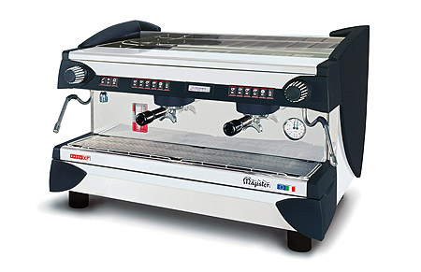
Fig2.3: Automatic coffee makes equipment
2.4.2 Office automation:
We use systems like fax machine, modem, printer etc…
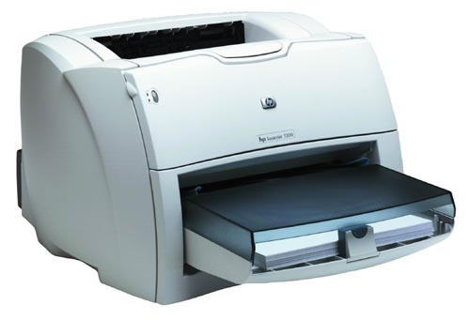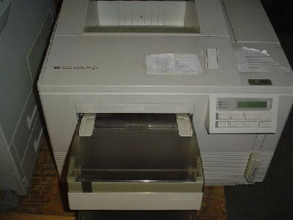
Fig2.4: Fax machine Fig2.5: Printing machine

2.4.3. Industrial automation:
Today a lot of industries are using embedded systems for process control. In industries we design the embedded systems to perform a specific operation like monitoring temperature, pressure, humidity ,voltage, current etc.., and basing on these monitored levels we do control other devices, we can send information to a centralized monitoring station.
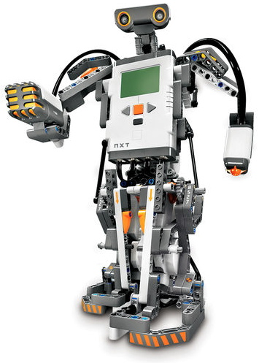
Fig2.6: Robot
In critical industries where human presence is avoided there we can use robots which are programmed to do a specific operation.
2.4.5 Computer networking:
Embedded systems are used as bridges routers etc..
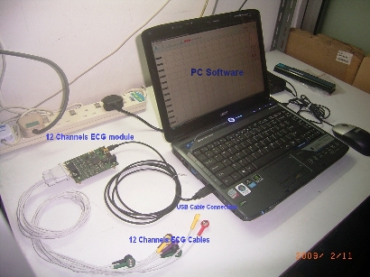
Fig2.7: Computer networking

CHAPTER 3: HARDWARE DESCRIPTION

3.1 Introduction:
In this chapter the block diagram of the project and design aspect of independent modules are considered. Block diagram is shown in fig:
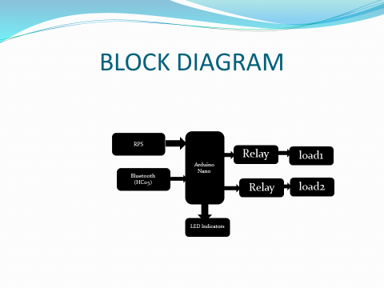

The main blocks of this project are:
  - Micro controller
  - Regulated power supply (RPS)
  - LED indicator.
  - Bluetooth module
  - DC motor
  - LCD
  - Relay

3.2.1 Introduction to Microcontrollers:
Circumstances that we find ourselves in today in the field of microcontrollers had their beginnings in the development of technology of integrated circuits. This development has made it possible to store hundreds of thousands of transistors into one chip. That was a prerequisite for production of microprocessors, and the first computers were made by adding external peripherals such as memory, input-output lines, timers and other. Further increasing of the volume of the package resulted in creation of integrated circuits. These integrated circuits contained both processor and peripherals. That is how the first chip containing a microcomputer, or what would later be known as a microcontroller came about.
Microprocessors and microcontrollers are widely used in embedded systems products. Microcontroller is a programmable device. A microcontroller has a CPU in addition to a fixed amount of RAM, ROM, I/O ports and a timer embedded all on a single chip. The fixed amount of on-chip ROM, RAM and number of I/O ports in microcontrollers makes them ideal for many applications in which cost and space are critical.
ARDUINO NANO BOARD
The Arduino Nano is a small, complete, and breadboard-friendly board based on the ATmega328P (Arduino Nano 3.x). It has more or less the same functionality of the Arduino Duemilanove, but in a different package. It lacks only a DC power jack, and works with a Mini-B USB cable instead of a 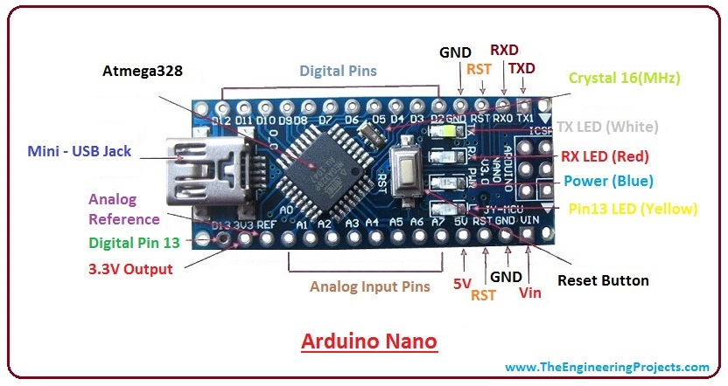standard one.
The Nano board is the first in a series of USB Arduino boards, and the reference model for the Arduino platform; for an extensive list of current, past or outdated boards see the Arduino index of boards.

Arduino Board
ATMEGA 328P FEATURES
Microcontroller | ATmega328
Architecture | AVR
Operating Voltage | 5 V
Flash Memory | 32 KB of which 2 KB used by bootloader
SRAM | 2 KB
Clock Speed | 16 MHz
Analog IN Pins | 8
EEPROM | 1 KB
DC Current per I/O Pins | 40 mA (I/O Pins)
Input Voltage | 7-12 V
Digital I/O Pins | 22 (6 of which are PWM)
PWM Output | 6
Power Consumption | 19 mA
PCB Size | 18 x 45 mm
Weight | 7 g
Product Code | A000005

DESCRIPTION

Power
The Arduino Nano can be powered via the Mini-B USB connection, 6-20V unregulated external power supply (pin 30), or 5V regulated external power supply (pin 27). The power source is automatically selected to the highest voltage source.
Memory
The ATmega328P has 32 KB, (also with 2 KB used for the bootloader. The ATmega328P has 2 KB of SRAM and 1 KB of EEPROM.

Input and Output
Each of the 14 digital pins on the Nano can be used as an input or output, using pin Mode (), digitalWrite (), and digital Read () functions. They operate at 5 volts. Each pin can provide or receive a maximum of 40 mA and has an internal pull-up resistor (disconnected by default) of 20-50 Kilo ohms. In addition, some pins have specialized functions:
- Serial: 0 (RX) and 1 (TX). Used to receive (RX) and transmit (TX) TTL serial data. These pins are connected to the corresponding pins of the FTDI USB-to-TTL Serial chip.
- External Interrupts: 2 and 3. These pins can be configured to trigger an interrupt on a low value, a rising or falling edge, or a change in value. See the attach Interrupt () function for details.
- PWM: 3, 5, 6, 9, 10, and 11. Provide 8-bit PWM output with the analog Write () function.
- SPI: 10 (SS), 11 (MOSI), 12 (MISO), 13 (SCK). These pins support SPI communication, which, although provided by the underlying hardware, is not currently included in the Arduino language.
- LED: 13. There is a built-in LED connected to digital pin 13. When the pin is HIGH value, the LED is on, when the pin is LOW, it's off.
The Nano has 8 analog inputs, each of which provides 10 bits of resolution (i.e. 1024 different values). By default they measure from ground to 5 volts, though is it possible to change the upper end of their range using the analog Reference () function. Analog pins 6 and 7 cannot be used as digital pins. Additionally, some pins have specialized functionality:
- I2C: A4 (SDA) and A5 (SCL). Support I2C (TWI) communication using the Wire library (documentation on the Wiring website).
There are a couple of other pins on the board:
- AREF. Reference voltage for the analog inputs. Used with analog Reference ().
- Reset. Bring this line LOW to reset the microcontroller. Typically used to add a reset button to shields which block the one on the board.

Communication
The Arduino Nano has a number of facilities for communicating with a computer, another Arduino, or other microcontrollers. The ATmega328P provide UART TTL (5V) serial communication, which is available on digital pins 0 (RX) and 1 (TX). An FTDI FT232RL on the board channels this serial communication over USB and the FTDI drivers (included with the Arduino software) provide a virtual com port to software on the computer. The Arduino software includes a serial monitor which allows simple textual data to be sent to and from the Arduino board. The RX and TX LEDs on the board will flash when data is being transmitted via the FTDI chip and USB connection to the computer (but not for serial communication on pins 0 and 1). A Software Serial library allows for serial communication on any of the Nano's digital pins. The ATmega328P also support I2C (TWI) and SPI communication. The Arduino software includes a Wire library to simplify use of the I2C bus. To use the SPI communication, please see ATmega328P datasheet.
Programming
The Arduino Nano can be programmed with the Arduino software (download). Select "Arduino Duemilanove or Nano w/ ATmega328P" from the Tools > Board menu (according to the microcontroller on your board). The ATmega328P on the Arduino Nano comes preburned with a bootloader that allows you to upload new code to it without the use of an external hardware programmer. It communicates using the original STK500 protocol. You can also bypass the bootloader and program the microcontroller through the ICSP (In-Circuit Serial Programming) header using Arduino ISP or similar.

Automatic (Software) Reset
Rather than requiring a physical press of the reset button before an upload, the Arduino Nano is designed in a way that allows it to be reset by software running on a connected computer. One of the hardware flow control lines (DTR) of the FT232RL is connected to the reset line of the ATmega328P via a 100 nanofarad capacitor. When this line is asserted (taken low), the reset line drops long enough to reset the chip. The Arduino software uses this capability to allow you to upload code by simply pressing the upload button in the Arduino environment. This means that the bootloader can have a shorter timeout, as the lowering of DTR can be well-coordinated with the start of the upload. This setup has other implications. When the Nano is connected to either a computer running Mac OS X or Linux, it resets each time a connection is made to it from software (via USB). For the following half-second or so, the bootloader is running on the Nano. While it is programmed to ignore malformed data (i.e. anything besides an upload of new code), it will intercept the first few bytes of data sent to the board after a connection is opened. If a sketch running on the board receives one-time configuration or other data when it first starts, make sure that the software with which it communicates waits a second after opening the connection and before sending this data.
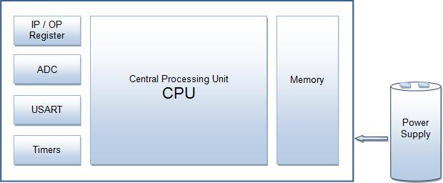
Block Diagram
PIN DIAGRAM
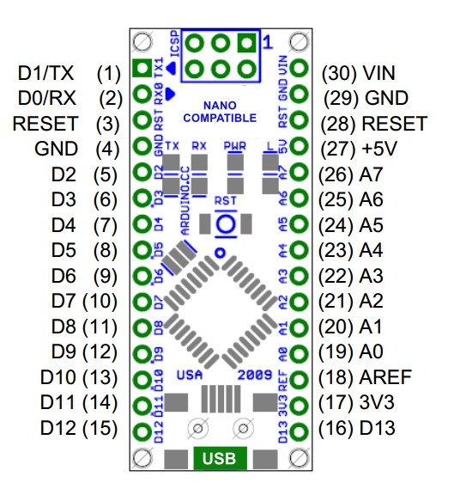
PIN DESCRIPTION
VCC
Digital supply voltage.
GND

- Arduino Nano Pinout contains 14 digital pins, 8 analog Pins, 2 Reset Pins & 6 Power Pins.
- Each of these Digital & Analog Pins are assigned with multiple functions but their main function is to be configured as input or output.
- They are acted as input pins when they are interfaced with sensors, but if you are driving some load then use them as output.
- Functions like pin Mode () and digital Write() are used to control the operations of digital pins while analogRead() is used to control analog pins.
- The analog pins come with a total resolution of 10bits which measure the value from zero to 5V.
- Arduino Nano comes with a crystal oscillator of frequency 16 MHz. It is used to produce a clock of precise frequency using constant voltage.
- There is one limitation using Arduino Nano i.e. it doesn’t come with DC power jack, means you can not supply external power source through a battery.
- This board doesn’t use standard USB for connection with a computer, instead, it comes with Mini USB support.
- Tiny size and breadboard friendly nature make this device an ideal choice for most of the applications where a size of the electronic components is of great concern.
- Flash memory is 16KB or 32KB that all depends on the Atmega board i.e. Atmega168 comes with 16KB of flash memory while Atmega328 comes with a flash memory of 32KB. Flash memory is used for storing code. The 2KB of memory out of total flash memory is used for a bootloader.

- The SRAM can vary from 1KB or 2KB and EEPROM is 512 bytes or 1KB for Atmega168 and Atmega328 respectively.
- This board is quite similar to other Arduino boards available in the market, but the small size makes this board stand out from others.
- It is programmed using Arduino IDE which is an Integrated Development Environment that runs both offline and online.
- No prior arrangements are required to run the board. All you need is board, mini USB cable and Arduino IDE software installed on the computer. USB cable is used to transfer the program from computer to the board.
- No separate burner is required to compile and burn the program as this board comes with a built-in boot-loader.
- Each pin on the Nano board comes with a specific function associated with it.
- We can see the analog pins that can be used as an analog to digital converter where A4 and A5 pins can also be used for I2C communication. Similarly, there are 14 digital pins, out of which 6 pins are used for generating PWM.
- Vin. It is input power supply voltage to the board when using an external power source of 7 to 12 V.
5V. It is a regulated power supply voltage of the board that is used to power the controller and other components placed on the board.
- 3.3V. This is a minimum voltage generated by the voltage regulator on the board.
- GND. These are the ground pins on the board. There are multiple ground pins on the board that can be interfaced accordingly when more than one ground pin is required.
- Reset. Reset pin is added on the board that resets the board. It is very helpful when running program goes too complex and hangs up the board. LOW value to the reset pin will reset the controller.
- Analog Pins. There are 8 analog pins on the board marked as A0 – A7. These pins are used to measure the analog voltage ranging between 0 t 5V.
- Rx, Tx. These pins are used for serial communication where Tx represents the transmission of data while Rx represents the data receiver.
- 13. This pin is used to turn on the built-in LED.
- AREF. This pin is used as a reference voltage for the input voltage.
- PWM. Six pins 3,5,6,9,10, 11 can be used for providing 8-pit PWM (Pulse Width Modulation) output. It is a method used for getting analog results with digital sources.
- SPI. Four pins 10(SS),11(MOSI),12(MISO),13(SCK) are used for SPI (Serial Peripheral Interface). SPI is an interface bus and mainly used to transfer data between microcontrollers and other peripherals like sensors, registers, and SD card.
- External Interrupts. Pin 2 and 3 are used as external interrupts which are used in case of emergency when we need to stop the main program and call important instructions at that point. The main program resumes once interrupt instruction is called and executed.
- I2C. I2C communication is developed using A4 and A5 pins where A4 represents the serial data line (SDA) which carries the data and A5 represents the serial clock line (SCL) which is a clock signal, generated by the master device, used for data synchronization between the devices on an I2C bus.

COMMUNICATION AND PROGRAMMING

- The Nano device comes with an ability to set up a communication with other controllers and computers. The serial communication is carried out by the digital pins like pin 0 (Rx) and pin 1 (TX) where Rx is used for receiving data and Tx is used for the transmission of data. The serial monitor is added on the Arduino Software which is used to transmit textual data to or from the board. FTDI drivers are also included in the software which behaves as a virtual com port to the software.
- The Tx and Rx pins come with an LED which blinks as the data is transmitted between FTDI and USB connection to the computer.
- Arduino Software Serial Library is used for carrying out a serial communication between the board and the computer.
- Apart from serial communication the Nano board also supports I2C and SPI communication. The Wire Library inside the Arduino Software is accessed to use the I2C bus.
- The Arduino Nano is programmed by Arduino Software called IDE which is a common software used for almost all types of board available. Simply download the software and select the board you are using. There are two options to program the controller i.e either by the bootloader that is added in the software which sets you free from the use of external burner to compile and burn the program into the controller and another option is by using ICSP (In-circuit serial programming header).
- Arduino board software is equally compatible with Windows, Linux or MAC, however, Windows are preferred to use.

RESET
There are two ways to reset the board i.e. electronically or programmatically. In order to reset the board electronically, you need to connect the reset pin of the board with any of digital pins on the controller. Don’t forget to add 1K or 2K Ohm resistor while setting up this connection. Now, use the digital pin as an output and keep it HIGH before the reset. Once the reset is required, set this digital pin to LOW. This method is very useful because using it sends a hardware reset signal to the controller once the digital pin is set to LOW. You can use the following program to reset the controller electronically.
Another method we can use to reset the board is by software only without using any hardware pin. Nano board comes with a built-in function known as resetFunc (). The board will reset automatically as we define this function and then call it. Without using any hardware pin you can upload the following program to reset the board programmatically.
However, this method comes with some limitations. Once the board is connected to the computer, the board will be reset each time the connection is laid out between the board and the computer. So, it is preferred to reset the controller electronically using a digital pin.

DIFFERENCE BETWEEN ARDUINO UNO AND NANO

- Both Arduino Uno and Arduino Nano come with same functionality with little difference in terms of PCB layout, size and form factor.
- Arduino Uno is a microcontroller board based on Atmega328 and comes with 14 digital I/O pins out of which 6 are PWM. There are 6 analog pins incorporated on the board. This board comes with everything required to support the microcontroller like USB connection, Power jack, 16MHz oscillator, reset button and ICSP header. You don’t require extra peripheral with the board to make it work for automation.
- It is a complete ready to use device that requires no prior technical skills to get a hands-on experience with it. You can power it by using DC power jack, battery or simply plug it to the computer using a USB cable to get started.
- Arduino Nano is small and compact as compared to Arduino Uno. It lacks the DC power jack and comes with Mini USB support instead of regular USB. Also, Nano board comes with two extra analog pins i.e. 8 pins as compared to 6 analog pins in Uno board. Nano board is breadboard friendly while Uno board lacks this property.
- However, both devices run at 5V, come with a current rating of 40mA, and 16MHz of the clock frequency.

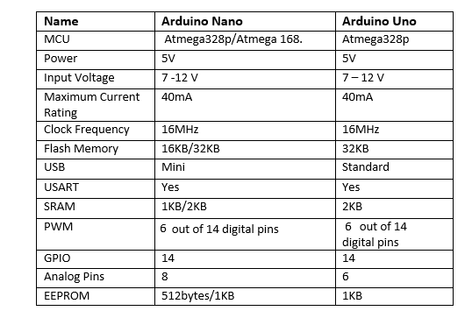

APPLICATIONS
Arduino Nano is a very useful device that comes with a wide range of applications and covers less space as compared to other Arduino board. Breadboard friendly nature makes it stand out from other board. Following are the main applications of the board.
- Arduino Metal Detector
- Medical Instruments
- Industrial Automation
- Android Applications
- GSM Based Projects
- Automation and Robotics
- Home Automation and Defense Systems
- Virtual Reality Applications

3.3 REGULATED POWER SUPPLY:
3.3.1 Introduction:
Power supply is a supply of electrical power. A device or system that supplies electrical or other types of energy to an output load or group of loads is called a power supply unit or PSU. The term is most commonly applied to electrical energy supplies, less often to mechanical ones, and rarely to others.
A power supply may include a power distribution system as well as primary or secondary sources of energy such as
- Conversion of one form of electrical power to another desired form and voltage, typically involving converting AC line voltage to a well-regulated lower-voltage DC for electronic devices. Low voltage, low power DC power supply units are commonly integrated with the devices they supply, such as computers and household electronics.
- Batteries.
- Chemical fuel cells and other forms of energy storage systems.
- Solar power.
- Generators or alternators.
- 3.3.2 Block Diagram:

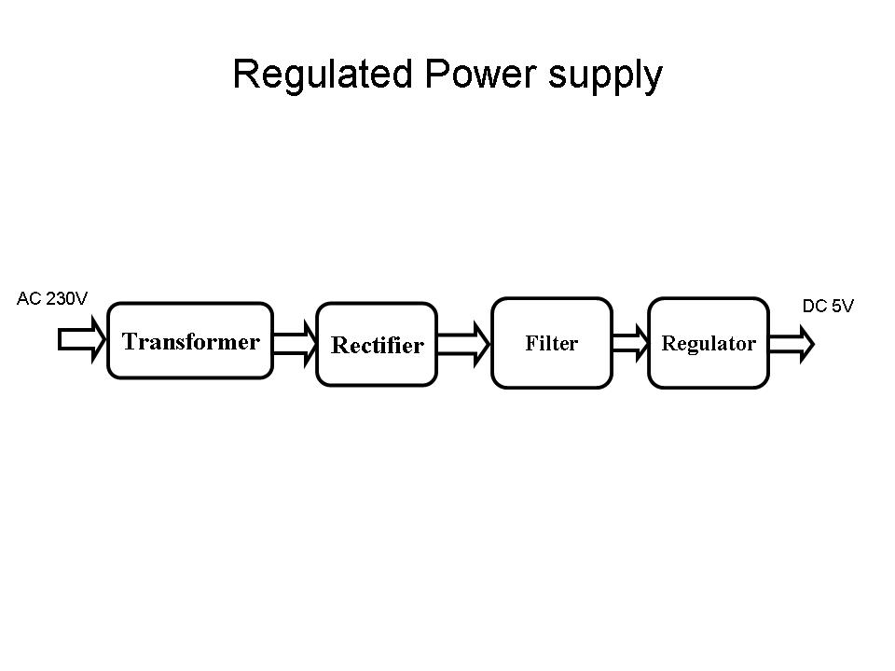 Fig 3.3.2 Regulated Power Supply
The basic circuit diagram of a regulated power supply (DC O/P) with led connected as load is shown in fig: 3.3.3.
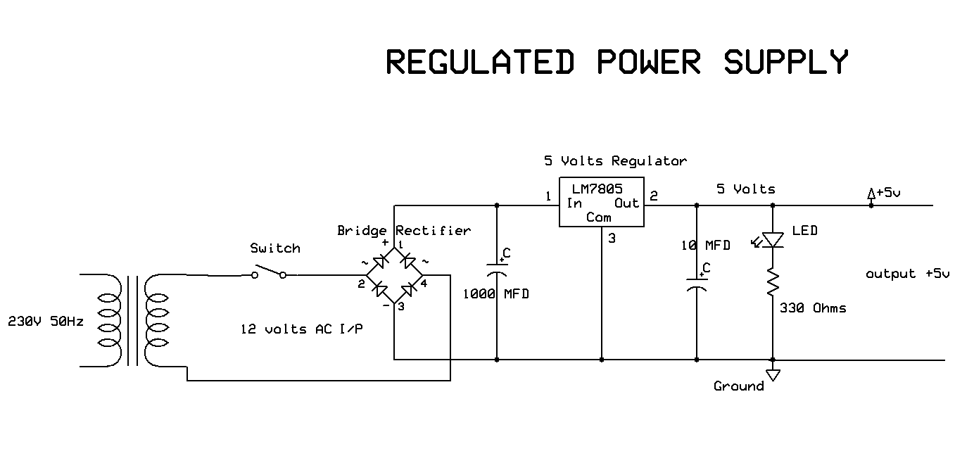
Fig 3.3.3 Circuit diagram of Regulated Power Supply with Led connection

The components mainly used in above figure are
- 230V AC MAINS
- TRANSFORMER
- BRIDGE RECTIFIER(DIODES)
- CAPACITOR
- VOLTAGE REGULATOR(IC 7805)
- RESISTOR
- LED(LIGHT EMITTING DIODE)
The detailed explanation of each and every component mentioned above is as follows:
Transformation: The process of transforming energy from one device to another is called transformation. For transforming energy we use transformers.
Transformers:
A transformer is a device that transfers electrical energy from one circuit to another through inductively coupled conductors without changing its frequency. A varying current in the first or primary winding creates a varying magnetic flux in the transformer's core, and thus a varying magnetic field through the secondary winding. This varying magnetic field induces a varying electromotive force (EMF) or "voltage" in the secondary winding. This effect is called mutual induction.

the 50 Hz AC mains supply, this will happen 50 times a second. This is called MUTUAL INDUCTION and forms the basis of the transformer.
The input coil is called the PRIMARY WINDING; the output coil is the SECONDARY WINDING. Fig: 3.3.4 shows step-down transformer If a load is connected to the secondary, an electric current will flow in the secondary winding and electrical energy will be transferred from the primary circuit through the transformer to the load. This field is made up from lines of force and has the same shape as a bar magnet.
If the current is increased, the lines of force move outwards from the coil. If the current is reduced, the lines of force move inwards.
If another coil is placed adjacent to the first coil then, as the field moves out or in, the moving lines of force will "cut" the turns of the second coil. As it does this, a voltage is induced in the second coil. With.
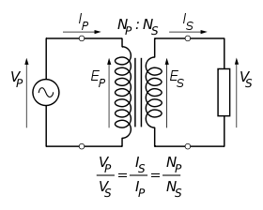
Fig 3.3.4: Step-Down Transformer
The voltage induced in the secondary is determined by the TURNS RATIO.
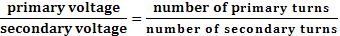
For example, if the secondary has half the primary turns; the secondary will have half the primary voltage.
Another example is if the primary has 5000 turns and the secondary has 500 turns, then the turn’s ratio is 10:1.
If the primary voltage is 240 volts then the secondary voltage will be x 10 smaller = 24 volts. Assuming a perfect transformer, the power provided by the primary must equal the power taken by a load on the secondary. If a 24-watt lamp is connected across a 24 volt secondary, then the primary must supply 24 watts.
To aid magnetic coupling between primary and secondary, the coils are wound on a metal CORE. Since the primary would induce power, called EDDY CURRENTS, into this core, the core is LAMINATED. This means that it is made up from metal sheets insulated from each other. Transformers to work at higher frequencies have an iron dust core or no core at all.
Note that the transformer only works on AC, which has a constantly changing current and moving field. DC has a steady current and therefore a steady field and there would be no induction.
Some transformers have an electrostatic screen between primary and secondary. This is to prevent some types of interference being fed from the equipment down into the mains supply, or in the other direction. Transformers are sometimes used for IMPEDANCE MATCHING.
We can use the transformers as step up or step down.
Step Up transformer:
In case of step up transformer, primary windings are every less compared to secondary winding. Because of having more turns secondary winding accepts more energy, and it releases more voltage at the output side.
Step down transformer:
Incase of step down transformer, Primary winding induces more flux than the secondary winding, and secondary winding is having less number of turns because of that it accepts less number of flux, and releases less amount of voltage.
Battery power supply:
A battery is a type of linear power supply that offers benefits that traditional line-operated power supplies lack: mobility, portability and reliability. A battery consists of multiple electrochemical cells connected to provide the voltage desired. Fig: 3.3.5 shows Hi-Watt 9V battery
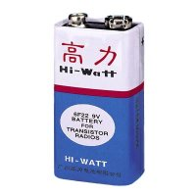
Fig 3.3.5: Hi-Watt 9V Battery
The most commonly used dry-cell battery is the carbon-zinc dry cell battery. Dry-cell batteries are made by stacking a carbon plate, a layer of electrolyte paste, and a zinc plate alternately until the desired total voltage is achieved. The most common dry-cell batteries have one of the following voltages: 1.5, 3, 6, 9, 22.5, 45, and 90. During the discharge of a carbon-zinc battery, the zinc metal is converted to a zinc salt in the electrolyte, and magnesium dioxide is reduced at the carbon electrode. These actions establish a voltage of approximately 1.5 V.
The lead-acid storage battery may be used. This battery is rechargeable; it consists of lead and lead/dioxide electrodes which are immersed in sulfuric acid. When fully charged, this type of battery has a 2.06-2.14 V potential (A 12 volt car battery uses 6 cells in series). During discharge, the lead is converted to lead sulfate and the sulfuric acid is converted to water. When the battery is charging, the lead sulfate is converted back to lead and lead dioxide A nickel-cadmium battery has become more popular in recent years. This battery cell is completely sealed and rechargeable. The electrolyte is not involved in the electrode reaction, making the voltage constant over the span of the batteries long service life. During the charging process, nickel oxide is oxidized to its higher oxidation state and cadmium oxide is reduced. The nickel-cadmium batteries have many benefits. They can be stored both charged and uncharged. They have a long service life, high current availabilities, constant voltage, and the ability to be recharged. Fig: 3.3.6 shows pencil battery of 1.5V.
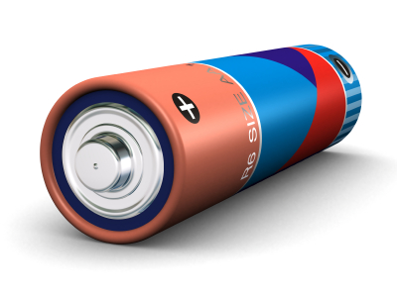Fig 3.3.6: Pencil Battery of 1.5V

Rectification:
The process of converting an alternating current to a pulsating direct current is called as rectification. For rectification purpose we use rectifiers.
Rectifiers:
A rectifier is an electrical device that converts alternating current (AC) to direct current (DC), a process known as rectification. Rectifiers have many uses including as components of power supplies and as detectors of radio signals. Rectifiers may be made of solid-state diodes, vacuum tube diodes, mercury arc valves, and other components.
A device that it can perform the opposite function (converting DC to AC) is known as an inverter.
When only one diode is used to rectify AC (by blocking the negative or positive portion of the waveform), the difference between the term diode and the term rectifier is merely one of usage, i.e., the term rectifier describes a diode that is being used to convert AC to DC. Almost all rectifiers comprise a number of diodes in a specific arrangement for more efficiently converting AC to DC than is possible with only one diode. Before the development of silicon semiconductor rectifiers, vacuum tube diodes and copper (I) oxide or selenium rectifier stacks were used.
Bridge full wave rectifier:
The Bridge rectifier circuit is shown in fig: 3.3.7, which converts an ac voltage to dc voltage using both half cycles of the input ac voltage. The Bridge rectifier circuit is shown in the figure. The circuit has four diodes connected to form a bridge. The ac input voltage is applied to the diagonally opposite ends of the bridge. The load resistance is connected between the other two ends of the bridge.
For the positive half cycle of the input ac voltage, diodes D1 and D3 conduct, whereas diodes D2 and D4 remain in the OFF state. The conducting diodes will be in series with the load resistance R_{L} and hence the load current flows through R_{L.}
For the negative half cycle of the input ac voltage, diodes D2 and D4 conduct whereas, D1 and D3 remain OFF. The conducting diodes D2 and D4 will be in series with the load resistance R_{L} and hence the current flows through R_{L} in the same direction as in the previous half cycle. Thus a bi-directional wave is converted into a unidirectional wave.
Input Output
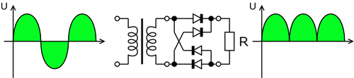

Fig 3.3.7: Bridge rectifier: a full-wave rectifier using 4 diodes
DB107:
Now -a -days Bridge rectifier is available in IC with a number of DB107. In our project we are using an IC in place of bridge rectifier. The picture of DB 107 is shown in fig: 3.3.8.
Features:
- Good for automation insertion
- Surge overload rating - 30 amperes peak
- Ideal for printed circuit board
- Reliable low cost construction utilizing molded
- Glass passivated device
- Polarity symbols molded on body
- Mounting position: Any
- Weight: 1.0 gram
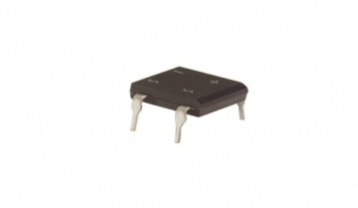
Fig 3.3.8: DB107
Filtration:
The process of converting a pulsating direct current to a pure direct current using filters is called as filtration.
Filters:
Electronic filters are electronic circuits, which perform signal-processing functions, specifically to remove unwanted frequency components from the signal, to enhance wanted ones.
Introduction to Capacitors:
The Capacitor or sometimes referred to as a Condenser is a passive device, and one which stores energy in the form of an electrostatic field which produces a potential (static voltage) across its plates. In its basic form a capacitor consists of two parallel conductive plates that are not connected but are electrically separated either by air or by an insulating material called the Dielectric. When a voltage is applied to these plates, a current flows charging up the plates with electrons giving one plate a positive charge and the other plate an equal and opposite negative charge this flow of electrons to the plates is known as the Charging Current and continues to flow until the voltage across the plates (and hence the capacitor) is equal to the applied voltage Vcc. At this point the capacitor is said to be fully charged and this is illustrated below. The construction of capacitor and an electrolytic capacitor are shown in figures 3.3.9 and 3.3.10 respectively.
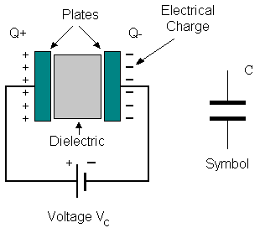
Fig 3.3.9:Construction Of a Capacitor Fig 3.3.10:Electrolytic Capaticor
Units of Capacitance:
Microfarad (μF) 1μF = 1/1,000,000 = 0.000001 = 10⁻⁶ F
Nanofarad (nF) 1nF = 1/1,000,000,000 = 0.000000001 = 10⁻⁹ F
Pico farad (pF) 1pF = 1/1,000,000,000,000 = 0.000000000001 = 10⁻¹² F
Operation of Capacitor:
Think of water flowing through a pipe. If we imagine a capacitor as being a storage tank with an inlet and an outlet pipe, it is possible to show approximately how an electronic capacitor works.
First, let's consider the case of a "coupling capacitor" where the capacitor is used to connect a signal from one part of a circuit to another but without allowing any direct current to flow.
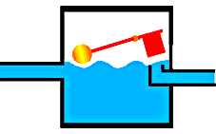 | If the current flow is alternating between zero and a maximum, our "storage tank" capacitor will allow the current waves to pass through.
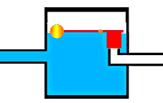 | However, if there is a steady current, only the initial short burst will flow until the "floating ball valve" closes and stops further flow.
So a coupling capacitor allows "alternating current" to pass through because the ball valve doesn't get a chance to close as the waves go up and down. However, a steady current quickly fills the tank so that all flow stops.
A capacitor will pass alternating current but (apart from an initial surge) it will not pass d.c.
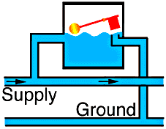 | Where a capacitor is used to decouple a circuit, the effect is to "smooth out ripples". Any ripples, waves or pulses of current are passed to ground while d.c. Flows smoothly.
Regulation:
The process of converting a varying voltage to a constant regulated voltage is called as regulation. For the process of regulation we use voltage regulators.
Voltage Regulator:
A voltage regulator (also called a ‘regulator’) with only three terminals appears to be a simple device, but it is in fact a very complex integrated circuit. It converts a varying input voltage into a constant ‘regulated’ output voltage. Voltage Regulators are available in a variety of outputs like 5V, 6V, 9V, 12V and 15V. The LM78XX series of voltage regulators are designed for positive input. For applications requiring negative input, the LM79XX series is used. Using a pair of ‘voltage-divider’ resistors can increase the output voltage of a regulator circuit.
It is not possible to obtain a voltage lower than the stated rating. You cannot use a 12V regulator to make a 5V power supply. Voltage regulators are very robust. These can withstand over-current draw due to short circuits and also over-heating. In both cases, the regulator will cut off before any damage occurs. The only way to destroy a regulator is to apply reverse voltage to its input. Reverse polarity destroys the regulator almost instantly. Fig: 3.3.11 shows voltage regulator.
Fig 3.11: Voltage Regulator
Resistors:
A resistor is a two-terminal electronic component that produces a voltage across its terminals that is proportional to the electric current passing through it in accordance with Ohm's law:
V = IR
Resistors are elements of electrical networks and electronic circuits and are ubiquitous in most electronic equipment. Practical resistors can be made of various compounds and films, as well as resistance wire (wire made of a high-resistivity alloy, such as nickel/chrome).
The primary characteristics of a resistor are the resistance, the tolerance, maximum working voltage and the power rating. Other characteristics include temperature coefficient, noise, and inductance. Less well-known is critical resistance, the value below which power dissipation limits the maximum permitted current flow, and above which the limit is applied voltage. Critical resistance is determined by the design, materials and dimensions of the resistor.
Resistors can be made to control the flow of current, to work as Voltage dividers, to dissipate power and it can shape electrical waves when used in combination of other components. Basic unit is ohms.

Power dissipation:
The power dissipated by a resistor (or the equivalent resistance of a resistor network) is calculated using the following:
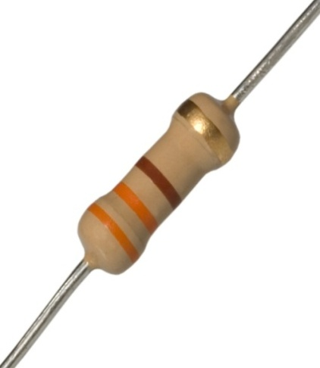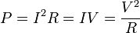
Fig: Resistor
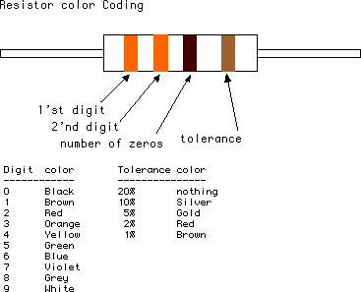 Fig 3.13: Color Bands In Resistor

3.4. LED:
A light-emitting diode (LED) is a semiconductor light source. LEDs are used as indicator lamps in many devices, and are increasingly used for lighting. Introduced as a practical electronic component in 1962, early LEDs emitted low-intensity red light, but modern versions are available across the visible, ultraviolet and infrared wavelengths, with very high brightness. The internal structure and parts of a led are shown in figures 3.4.1 and 3.4.2 respectively.
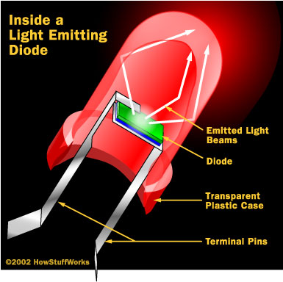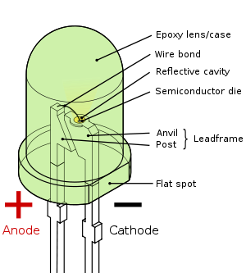
Fig 3.4.1: Inside a LED Fig 3.4.2: Parts of a LED

Working:
The structure of the LED light is completely different than that of the light bulb. Amazingly, the LED has a simple and strong structure. The light-emitting semiconductor material is what determines the LED's color. The LED is based on the semiconductor diode.
When a diode is forward biased (switched on), electrons are able to recombine with holes within the device, releasing energy in the form of photons. This effect is called electroluminescence and the color of the light (corresponding to the energy of the photon) is determined by the energy gap of the semiconductor. An LED is usually small in area (less than 1 mm²), and integrated optical components are used to shape its radiation pattern and assist in reflection. LEDs present many advantages over incandescent light sources including lower energy consumption, longer lifetime, improved robustness, smaller size, faster switching, and greater durability and reliability. However, they are relatively expensive and require more precise current and heat management than traditional light sources. Current LED products for general lighting are more expensive to buy than fluorescent lamp sources of comparable output. They also enjoy use in applications as diverse as replacements for traditional light sources in automotive lighting (particularly indicators) and in traffic signals. The compact size of LEDs has allowed new text and video displays and sensors to be developed, while their high switching rates are useful in advanced communications technology. The electrical symbol and polarities of led are shown in fig: 3.4.3.
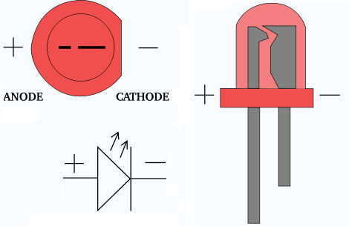
Fig 3.4.3: Electrical Symbol & Polarities of LED
LED lights have a variety of advantages over other light sources:
- High-levels of brightness and intensity
- High-efficiency
- Low-voltage and current requirements
- Low radiated heat
- High reliability (resistant to shock and vibration)
- No UV Rays
- Long source life
Can be easily controlled and programmed
Applications of LED fall into three major categories:
- Visual signal application where the light goes more or less directly from the LED to the human eye, to convey a message or meaning.
- Illumination where LED light is reflected from object to give visual response of these objects.
- Generate light for measuring and interacting with processes that do not involve the human visual system .

INTRODUCTION
- ESP8266 WI-FI MODULE
- ESP8266 gives a whole and self-contained Wi-Fi networking answer, allowing it to each host the software program or to dump all Wi-Fi networking abilities from a few one-of-a-type utility
- When ESP8266 hosts the software program utility, and while it's far the only software processor inside the tool, it could boot up immediately from an outdoor flash. It has covered cache to beautify the overall performance of the device in such packages, and to lower the reminiscence requirements. Alternately, serving as a Wi-Fi adapter, Wi-Fi net get admission to can be brought to any microcontroller-based format with clean connectivity via UART interface or the CPU AHB bridge interface. ESP8266 on-board processing and storage competencies permit it to be protected with the sensors and wonderful software program particular devices through its GPIOs with minimal development up-the the front and minimum loading throughout runtime. With its immoderate degree of on-chip integration, which includes the antenna switch balloon, electricity control converters, it calls for minimum outside circuitry, and the entire solution, collectively with the front-quit module, is designed to occupy minimum PCB vicinity.

- Fig: ESP8266

- PIN CONFIGURATION
- 1. Vcc
- 2. RST
- 3. CH_PD
- 4. TXD
- 5. RXD
- 6. GPIO0
- 7. GPI02
- 8. GND
- HARDWARE CONFIGURATIONS:
- • Device is operating with voltage diploma 3.3V
- • GPIO pins may be used for firmware flashing motive
- • RESET and POWER DOWN pins are energetic low pins. These must be maintained in energetic
- Immoderate style (Should provide three.3V for RST and PD pins) for normal operation of the device. RX pin to TX and TX to RX configuration.
BAUD RATE:
- Baud charge is predicated upon on firmware version (115200 or 57600 or 9600 is based totally upon on firmware).
- In ultra-modern firmware, the default baud price is 9600.
- We can exchange the baud fee as in keeping with our requirement, so you can be stored in non-unstable memory.
- HYPERTERMINAL CONFIGURATION:
- Baud fee should be 9600 (primarily based mostly on firmware).
- After making the relationship, go to File –
- Properties. In Settings tab, select out ASCII Setup…
- In ASCII receiving block, test the choice for Append line feeds to incoming line ends.
Basic AT Commands for Wi-Fi Module

        - Table: ESP8266 Commands.

3.7 DC motor
D.C. Motor:
A dc motor uses electrical energy to produce mechanical energy, very typically through the interaction of magnetic fields and current-carrying conductors. The reverse process, producing electrical energy from mechanical energy, is accomplished by an alternator, generator or dynamo. Many types of electric motors can be run as generators, and vice versa. The input of a DC motor is current/voltage and its output is torque (speed).

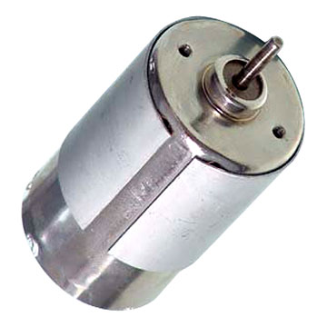
Fig 3.19: DC Motor
The DC motor has two basic parts: the rotating part that is called the armature and the stationary part that includes coils of wire called the field coils. The stationary part is also called the stator. Figure shows a picture of a typical DC motor, Figure shows a picture of a DC armature, and Fig shows a picture of a typical stator. From the picture you can see the armature is made of coils of wire wrapped around the core, and the core has an extended shaft that rotates on bearings. You should also notice that the ends of each coil of wire on the armature are terminated at one end of the armature. The termination points are called the commutator, and this is where the brushes make electrical contact to bring electrical current from the stationary part to the rotating part of the machine.
Operation:
The DC motor you will find in modem industrial applications operates very similarly to the simple DC motor described earlier in this chapter. Figure 12-9 shows an electrical diagram of a simple DC motor. Notice that the DC voltage is applied directly to the field winding and the brushes. The armature and the field are both shown as a coil of wire. In later diagrams, a field resistor will be added in series with the field to control the motor speed. When voltage is applied to the motor, current begins to flow through the field coil from the negative terminal to the positive terminal. This sets up a strong magnetic field in the field winding. Current also begins to flow through the brushes into a commutator segment and then through an armature coil. The current continues to flow through the coil back to the brush that is attached to other end of the coil and returns to the DC power source. The current flowing in the armature coil sets up a strong magnetic field in the armature.
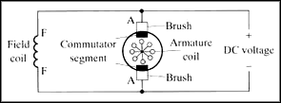
Fig 3.20: Simple electrical diagram of DC motor
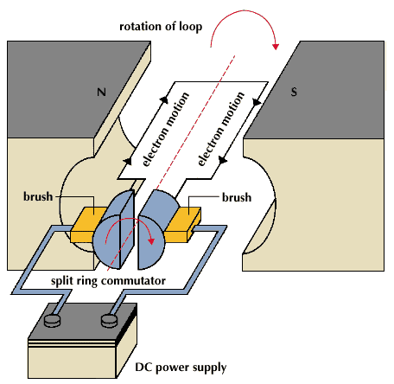
Fig 3.21: Operation of a DC Motor
The magnetic field in the armature and field coil causes the armature to begin to rotate. This occurs by the unlike magnetic poles attracting each other and the like magnetic poles repelling each other. As the armature begins to rotate, the commutator segments will also begin to move under the brushes. As an individual commutator segment moves under the brush connected to positive voltage, it will become positive, and when it moves under a brush connected to negative voltage it will become negative. In this way, the commutator segments continually change polarity from positive to negative. Since the commutator segments are connected to the ends of the wires that make up the field winding in the armature, it causes the magnetic field in the armature to change polarity continually from north pole to south pole. The commutator segments and brushes are aligned in such a way that the switch in polarity of the armature coincides with the location of the armature's magnetic field and the field winding's magnetic field. The switching action is timed so that the armature will not lock up magnetically with the field. Instead the magnetic fields tend to build on each other and provide additional torque to keep the motor shaft rotating.
When the voltage is de-energized to the motor, the magnetic fields in the armature and the field winding will quickly diminish and the armature shaft's speed will begin to drop to zero. If voltage is applied to the motor again, the magnetic fields will strengthen and the armature will begin to rotate again.
Applications of DC Motors:
1. Electric Train: A kind of DC motor called the DC Series Motor is used in Electric Trains. The DC Series Motors have the property to deliver more power when they are loaded more. So the more the people get on a train, the more powerful the train becomes.
2. Elevators: The best bidirectional motors are DC motors. They are used in elevators. Compound DC Motors are used for this application.
3. PC Fans, CD ROM Drives, and Hard Drives: All these things need motors, very miniature motors, with great precision. AC motors can never imagine any application in these places.
4. Starter Motors in Automobiles: An automobile battery supplies DC, so a DC motor is best suited here. Also, you cannot start an engine with a small sized AC motor,
5. Electrical Machines Lab in Colleges.

Applications
BLDC motors fulfill many functions originally performed by brushed DC motors, but cost and control complexity prevents BLDC motors from replacing brushed motors completely in the lowest-cost areas. Nevertheless, DC motors have come to dominate many applications, particularly devices such as computer hard drives and CD/DVD players. Small cooling fans in electronic equipment are powered exclusively by BLDC motors. They can be found in cordless power tools where the increased efficiency of the motor leads to longer periods of use before the battery needs to be charged. Low speed, low power BLDC motors are used in direct-drive turntables for "analog" audio discs.

Transport
High power BLDC motors are found in electric vehicles and hybrid vehicles. These motors are essentially AC synchronous motors with permanent magnet rotors.
The Segway Scooter and Vectrix Maxi-Scooter use BLDC technology.
A number of electric bicycles use BLDC motors that are sometimes built into the wheel hub itself, with the stator fixed solidly to the axle and the magnets attached to and rotating with the wheel. The bicycle wheel hub is the motor. This type of electric bicycle also has a standard bicycle transmission with pedals, sprockets, and chain that can be pedaled along with, or without, the use of the motor as need arises.^{[7]}

Heating and ventilation
There is a trend in the HVAC and refrigeration industries to use BLDC motors instead of various types of AC motors. The most significant reason to switch to a BLDC motor is the dramatic reduction in power required to operate them versus a typical AC motor.^{[8][9]} While shaded-pole and permanent split capacitor motors once dominated as the fan motor of choice, many fans are now run using a BLDC motor. Some fans use BLDC motors also in order to increase overall system efficiency.^{[10]}
In addition to the BLDC motor's higher efficiency, certain HVAC systems (especially those featuring variable-speed and/or load modulation) use BLDC motors because the built-in microprocessor allows for programmability, better control over airflow, and serial communication.

Industrial engineering
This section requires expansion.
See Stepper motor, Servo motor.

Stepper motor:
The stepper motor is used in microprocessor and microcontroller-based and robotic equipment, as it consumes less power and provides accurate movement of robotic arms. Semiconductor producers include Infineon Technologies, Texas Instruments and Microchip. Infineon offers so-called LIN stepper motors used in applications such as instrumentation and gauges, CNC machining, multi-axis positioning, printers and surveillance equipment.^{[11]}

Model engineering
BLDC motors are a popular motor choice for model aircraft including helicopters. Their favorable power-to-weight ratios and large range of available sizes, from under 5 gram to large motors rated at thousands of watts, have revolutionized the market for electric-powered model flight.
Their introduction has redefined performance in electric model aircraft and helicopters, displacing virtually all brushed electric motors. They have also encouraged a growth of simple, lightweight electric model aircraft, rather than the previous internal combustion engines powering larger and heavier models. The large power-to-weight ratio of modern batteries and brushless motors allows models to ascend vertically, rather than climb gradually. The low noise and lack of mess compared to small glow fuel internal combustion engines that are used is another reason for their popularity.
Legal restrictions for the use of combustion engine driven model aircraft in some countries have also supported the shift to high-power electric systems.
Their popularity has also risen in the Radio Controlled Car, Buggy, and Truck scene, where sensor-type motors (with an extra six wires, connected to Hall effect sensors) allow the position of the rotor magnet to be detected. Brushless motors have been legal in RC Car Racing in accordance to ROAR (the American governing body for RC Car Racing), since 2006. Several RC Car Brushless motors, feature replaceable and upgradeable parts, such as sintered neodymium-iron-boron (rare earth magnets), ceramic bearings, and replaceable motor timing assemblies. These motors as a result are quickly rising to be the preferred motor type for electric on and off-road RC racers and recreational drivers alike, for their low maintenance, high running reliability and power efficiency (most Sensored motors have an efficiency rating of 80% or greater).
PULSE WIDTH MODULATION (PWM):
Pulse-width modulation (PWM), or pulse-duration modulation (PDM), is a commonly used technique for controlling power to inertial electrical devices, made practical by modern electronic power switches.
The average value of voltage (and current) fed to the load is controlled by turning the switch between supply and load on and off at a fast pace. The longer the switch is on compared to the off periods, the higher the power supplied to the load is.
The PWM switching frequency has to be much faster than what would affect the load, which is to say the device that uses the power. Typically switching have to be done several times a minute in an electric stove, 120 Hz in a lamp dimmer, from few kilohertz (kHz) to tens of kHz for a motor drive and well into the tens or hundreds of kHz in audio amplifiers and computer power supplies.
The term duty cycle describes the proportion of 'on' time to the regular interval or 'period' of time; a low duty cycle corresponds to low power, because the power is off for most of the time. Duty cycle is expressed in percent, 100% being fully on.
The main advantage of PWM is that power loss in the switching devices is very low. When a switch is off there is practically no current, and when it is on, there is almost no voltage drop across the switch. Power loss, being the product of voltage and current, is thus in both cases close to zero. PWM also works well with digital controls, which, because of their on/off nature, can easily set the needed duty cycle. PWM has also been used in certain communication systems where its duty cycle has been used to convey information over a communications channel.

Communication and control :
One of the advantages of PWM is that the signal remains digital all the way from the processor to the controlled system; no digital-to-analog conversion is necessary. By keeping the signal digital, noise effects are minimized. Noise can only affect a digital signal if it is strong enough to change a logic-1 to a logic-0, or vice versa.
Increased noise immunity is yet another benefit of choosing PWM over analog control, and is the principal reason PWM is sometimes used for communication. Switching from an analog signal to PWM can increase the length of a communications channel dramatically. At the receiving end, a suitable RC (resistor-capacitor) or LC (inductor-capacitor) network can remove the modulating high frequency square wave and return the signal to analog form.
PWM finds application in a variety of systems. As a concrete example, consider a PWM-controlled brake. To put it simply, a brake is a device that clamps down hard on something. In many brakes, the amount of clamping pressure (or stopping power) is controlled with an analog input signal. The more voltage or current that's applied to the brake, the more pressure the brake will exert.
The output of a PWM controller could be connected to a switch between the supply and the brake. To produce more stopping power, the software need only increase the duty cycle of the PWM output. If a specific amount of braking pressure is desired, measurements would need to be taken to determine the mathematical relationship between duty cycle and pressure. (And the resulting formulae or lookup tables would be tweaked for operating temperature, surface wear, and so on.)
To set the pressure on the brake to, say, 100 psi, the software would do a reverse lookup to determine the duty cycle that should produce that amount of force. It would then set the PWM duty cycle to the new value and the brake would respond accordingly. If a sensor is available in the system, the duty cycle can be tweaked, under closed-loop control, until the desired pressure is precisely achieved.
PWM is economical, space saving, and noise immune. And it's now in your bag of tricks. So use it.

PWM controllers
Many microcontrollers include on-chip PWM controllers. For example, Microchip's PIC16C67 includes two, each of which has a selectable on-time and period. The duty cycle is the ratio of the on-time to the period; the modulating frequency is the inverse of the period. To start PWM operation, the data sheet suggests the software should:
- Set the period in the on-chip timer/counter that provides the modulating square wave
- Set the on-time in the PWM control register
- Set the direction of the PWM output, which is one of the general-purpose I/O pins
- Start the timer
- Enable the PWM controller
Although specific PWM controllers do vary in their programmatic details, the basic idea is generally the Same
BLUETOOTH:

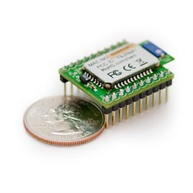 Bluetooth is an open wireless technology standard for exchanging data over short distances (using short wavelength radio transmissions) from fixed and mobile devices, creating personal area networks (PANs) with high levels of security. Created by telecoms vendor Ericsson in 1994 it was originally conceived as a wireless alternative to RS-232 data cables. It can connect several devices, overcoming problems of synchronization.

Bluetooth Overview

Why Bluetooth?
Bluetooth is a short-range radio link intended to replace the cable(s) connecting portable and/or fixed electronic devices. Key features are robustness, low complexity, low power and low cost ^{[1]}. There are already similar standards in this market, such as IrDA, Home RF and IEEE 802.11 family. Bluetooth is designed to offer some unique advantages that none of the others can provide.
For example, IrDA uses infrared as medium, so its range is limited to around 1 meter, and it requires a line-of-sight communication. In comparison, Bluetooth can operate at a range up to 10 meters, or even 100 meters with enhanced transmitters. RF signals goes through walls, so a Bluetooth network can span several rooms.
Compared with Home RF and IEEE 802.11 family, Bluetooth has much lower data rate and transmission range (10 meter). While Home RF supports 1.6 ~ 10 Mbps data rate and IEEE 802.11a/b supports 54/11 Mbps, Bluetooth supports only 780 Kbps, which can be used for 721 kbps downstream and 57.6 kbps upstream asymmetric data transfer, or 432.6 kbps symmetric data transfer. Both Home RF and IEEE 802.11 operate at 100 meter range, while Bluetooth operates at up to 10 meter.
However, as a result of the lower data rate and transmission range, Bluetooth offers much lower cost per node (approximately 5 ~ 10% of Home RF and IEEE 802.11). So it is more suitable for applications involving low data rate (data and voice), small number of devices (8 at maximum), low power consumption and short range (up to 10 meter), such as PC-to-peripheral networking, home networking, hidden computing, data synchronization (such as between PC and PDA), mobile phone devices, and future smart devices or entertainment equipment.

Bluetooth Architecture
The Bluetooth architecture and its mapping to OSI model
Bluetooth communication occurs between a master radio and a slave radio. Bluetooth radios are symmetric in that the same device may operate as a master and also the slave. Each radio has a 48-bit unique device address (BD_ADDR) that is fixed.
Two or more radio devices together form ad-hoc networks called piconets. All units within a piconet share the same channel. Each piconet has one master device and one or more slaves. There may be up to seven active slaves at a time within a piconet. Thus, each active device within a piconet is identifiable by a 3-bit active device address. Inactive slaves in unconnected modes may continue to reside within the piconet.
A master is the only one that may initiate a Bluetooth communication link. However, once a link is established, the slave may request a master/slave switch to become the master. Slaves are not allowed to talk to each other directly. All communication occurs within the slave and the master. Slaves within a piconet must also synchronize their internal clocks and frequency hops with that of the master. Each piconet uses a different frequency hopping sequence. Radio devices used Time Division Multiplexing (TDM). A master device in a piconet transmits on even numbered slots and the slaves may transmit on odd numbered slots.
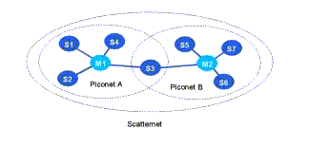
Fig 1: Bluetooth Scatter nets and Piconet
Multiple piconets with overlapping coverage areas form a scatternet. Each piconet may have only one master, but slaves may participate in different piconets on a time-division multiplex basis. A device may be a master in one piconet and a slave in another or a slave in more than one piconet

Protocols in Bluetooth Architecture

Bluetooth Core Protocols

Baseband

Link Manager Protocol

Logical Link Control and Adaptation Protocol

Service Discovery Protocol

Cable Replacement Protocol

Telephony Control Protocol

Adopted Protocols

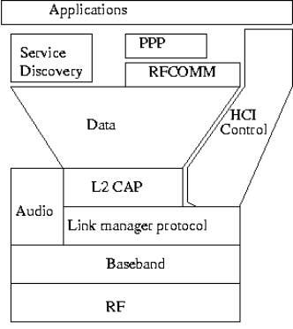
Above figure shows the Bluetooth protocol architecture.
Bluetooth technology is designed for and optimized for use in mobile devices. Mobile computers, cellular handsets, network access points, printers, PDA’s, desktops, keyboards, joysticks and virtually any other device can have short range Bluetooth radios operating in the free 2.4GHz Industrial-Scientific-Medical (ISM) band integrated into them (single chip). It uses Frequency Hop (FH) spread spectrum, which divides the frequency band into a number of hop channels. Bluetooth radios use tiny radio-frequency transmitters, no larger than 1.0 by 0.5 inches that can run off a watch battery for months. Power considerations are always important for battery-powered mobile devices, and Bluetooth’s low power modes meet those requirements with less than 0.1 W active power. And since Bluetooth is designed for both computing and communications applications, it is designed to support high quality simultaneous voice and data, with robust data transfer rates of up to 721 Kbps. IT supports both synchronous and asynchronous services and easy integration of TCP/IP for networking purposes.
The complete Bluetooth protocol stack has been designed to include the existing protocols as much as possible (like TCP, UDP, OBEX) as well as Bluetooth specific protocols like LMP and L2CAP. The protocol reuse ensures smooth interoperability between existing applications and hardware. The Specification is also open, thereby allowing vendors to build proprietary applications. Although different applications may run over different protocol stacks, they all use the Bluetooth data link and physical layers. The Applications layer lies on top of the vCard (internal object representation convention) layer.
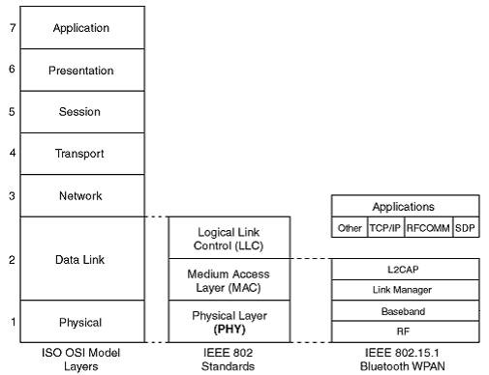

Topology | Supports up to 8 simultaneous links in a piconet
Flexibility | Goes through walls, bodies, clothes, ...
Data Rate | 1 MSPS, 721 Kbps
Power | 0.1 Watts active power
Size/Weight | 25 mm × 13 mm × 2 mm, several grams
Cost | Long term $5 per endpoint
Range | 10 meters or less; up to 100 meters with PA
Universal | Intended to work worldwide
Security | Very, link layer security, SS radio
Table 1: Bluetooth features at a glance.
Baseband:
The Baseband and Link Control Layer enables the RF link Bluetooth units in a piconet. This layer uses inquiry and paging procedures to synchronize the transmission between different Bluetooth devices.
Link Manager Protocol (LMP): The link manager protocol is responsible for setting up link channels between Bluetooth devices after performing security methods like authentication and encryption by generating, exchanging and verifying linking and encryption keys and negotiating baseband packet size.
Logical Link Control and Adaptation Protocol (L2CAP): L2CAP packets carry payloads which are carried to the upper layer protocols.
Service Discovery Protocol (SDP): Using SDP, device information, services allowed and characteristics of the services are queried between Bluetooth enabled devices.
Cable Replacement Protocol (RFCOMM): RFCOMM is a serial line emulation protocol.
Telephony Control Protocol: The Telephony Control - Binary (TCS Binary) and Telephony Control - AT Commands are used to establish speech and data calls between devices and control mobile phones and modems respectively.
Adopted Protocols: Bluetooth also supports PPP, TCP/UDP/IP, OBEX and WAP protocols to maximize interoperability.
For more details refer to the Bluetooth White Paper.

2. Bluetooth Topology
There can be only 2 ~ 8 Bluetooth devices talking to each other. This is called a piconet. Among these devices, there can be only one master device, all the rest are slave devices. A device can belong to two piconets meantime, serving as slaves in both piconet or a master in one and slave in another. This is called a bridging device. Bridging devices connect piconets together to form a scatternet:
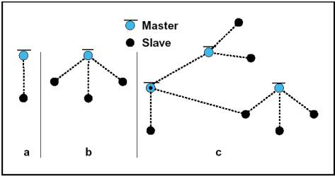
Figure 3: Single-slave piconet (a), multiple-slave piconet and scatternet (c)

3. RF and Baseband

3.1. RF

Bluetooth operates at the unlicensed 2.5GHz Industrial-Scientific-Medical (ISM) band. There are already many types of devices using this band, such as baby monitors and garage door remote controls. To avoid interfering with these devices, Bluetooth devices send out very weak signals (about 1 mill watt). This limits the transmission range to 10 meters. It also uses a frequency hopping technique, hopping randomly between 79 1-MHz channels 1600 times per second (625 us time slot). Each piconet is synchronized to a specific frequency hopping pattern, so that even different piconets do not interfere with each other. A piconet can either be static or dynamic (changing when devices move in or out).

3.2. Modulation

The modulation in Bluetooth is Gaussian Frequency Shift Keying (GFSK), with BT = 0.5 and modulation index between 0.25 and 0.35:

BLUETOOTH MODULATION (GFSK)
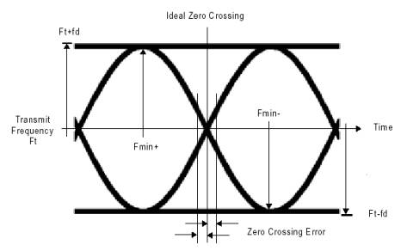

3.3. Physical Links
Bluetooth protocol uses a combination of synchronous and asynchronous links. A Synchronous Connection-Oriented (SCO) link is a point-to-point link between the master and specific slave. It has symmetric 64 kbps rate, typically used for voice transmission. It uses reserved time slots, thus can be regarded as a circuit switching link. A master can support up to 3 SCO links to one or multiple slaves, while a slave can support up to three SCO links to one master or up to two SCO links to different masters. Master transmits at reserved master-to-slave time slot, and slave response in the following slave-to-master slot. SCO packets are never retransmitted.
Asynchronous Connectionless (ACL) links are used for data transmission, with 723.2 downstream/57.6 kbps upstream asymmetric or 433.9 kbps symmetric data rate. There can be only one ACL link between the master and all active slaves. Only the addressed slave device can response. ACL packets can be retransmitted for data integrity.

3.4. Logical Channels
On top of physical links, there is a sub layer of logical channels, representing different types of information carried through the physical links. LC channel carries low-level link control information such as ARQ and flow control; LM channel carries messages for the Link Manager layer, UA, UI and US channel carries asynchronous, isochronous and synchronous user data respectively. LC channel is carried in the packet header, others are in the payload.

3.5. Packet Format
Data in piconet is encoded in packets. The general packet format is shown below:

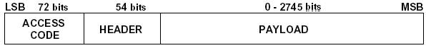
Figure 5: General Packet Format of Bluetooth ^{[1]}
A packet could contain a shorthanded access code (68 bytes) part of the parket only, or access code plus header, or all the three parts.

Access Code
Access code is used for synchronization, DC offset compensation and identification. It is show below:

Figure 6: Access Code Format of Bluetooth Packet ^{[1]}
There are three kinds of access codes. Channel Access Code (CAC) is used to identify the piconet. All packet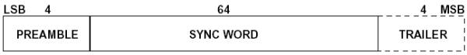s sent through one channel of the piconet carries the address of the master device. Device Access Code (DAC) is used for special signaling procedures, such as paging and response to paging. A DAC for paging carries the address of paged device. Each Bluetooth device has a unique address called BD_ADDR. It contains two parts: company ID which is unique across the world, and device ID which is unique within the products of the company. The Sync Word of the access code is derived from a BD_ADDR address using (64,30) expurgated block code with an overlay of an 64-bit full length PN sequence.
The preamble is simply a fixed “0101” or “1010” sequence depending on whether the LSB of the following sync word is “0” or “1”.
If there is no header following in the packet, the access code does not have a trailer.

Header
Header part of the packet is used by the Link Control (LC) logical channel. It has the following format:
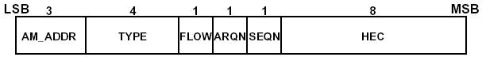
Figure 7: Header Format of Bluetooth Packet ^{[1]}
AM_ADDR: temporary address assigned to active members of the piconet, used on all packets in both direction sent between the master and the addressed slave. An all-zero AM_ADDR is used to broadcast to all slaves.
TYPE: type of packet. There are 12 types of packets for each SCO and ACL physical links, and four types of common control packets for both.
FLOW: for flow control.
ARQN: for ACK.
SEQN: contains sequence number for packet ordering.
HEC: header error check for header integrity.

3.6. Payload
There can be two types of payload: voice and data. SCO packets only have voice field, while ACL packets only have data field.

4. Link Manager
Link Manager messages are used for link setup, security and control. They are transferred in the payload part of the packet. LM messages are filtered out and interpreted by LM layer and are not passed to upper layers. LM messages have higher priority than upper-layer messages.

5. Logical Link Control and Adaption Protocol (L2CAP)
L2CAP layer operates over a single ACL link provided by the baseband, which is setup by the LM layers using LM messages. This ACL link is always available between the master and any slaves. L2CAP layer serves upper layer by transmitting data over channels (Fig. 8). Each channel has two end points and a logical channel ID (CID).
A channel is setup in the following procedure:
1. Connection
A L2CAP entity requests connection to a remote device. The request has been passed from upper layers of the first L2CAP entity. When a response is received, the local device enters Config state.
2. Configuration
Configuration process involves a negotiation between two end points of the channel over maximum transmission unit (MTU), a flush time out and quality of service (QoS) agreement. Once all these issues have been successfully negotiated, the two end points enters Open state, in which data transfer may begin.
3. Disconnection
When a L2CAP layer receives a disconnect request from upper layer, it passes it to the remote device. When response received, the channel enters Closed state.
APPLICATIONS OF BLUETOOTH
- Mobile computers
- Cellular handsets
- Network access points
- Printers, PDA’s, desktops, keyboards, joysticks
BLUETOOTH DONGLE:
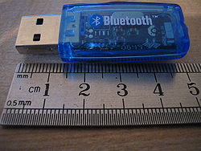
Bluetooth is an open wireless technology standard for exchanging data over short distances (using short wavelength radio transmissions) from fixed and mobile devices, creating personal area networks (PANs) with high levels of security. Created by telecoms vendor Ericsson in 1994,^{[1]} it was originally conceived as a wireless alternative to RS-232 data cables. It can connect several devices, overcoming problems of synchronization. Today Bluetooth is managed by the Bluetooth Special Interest Group.

RELAY:
A relay is an electrically operated switch. Many relays use an electromagnet to operate a switching mechanism, but other operating principles are also used. Relays find applications where it is necessary to control a circuit by a low-power signal, or where several circuits must be controlled by one signal. The first relays were used in long distance telegraph circuits, repeating the signal coming in from one circuit and re-transmitting it to another. Relays found extensive use in telephone exchanges and early computers to perform logical operations. A type of relay that can handle the high power required to directly drive an electric motor is called a contactor. Solid-state relays control power circuits with no moving parts, instead using a semiconductor device triggered by light to perform switching. Relays with calibrated operating characteristics and sometimes multiple operating coils are used to protect electrical circuits from overload or faults; in modern electric power systems these functions are performed by digital instruments still called "protection relays".

Basic design and operation:
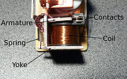

Simple electromechanical relay
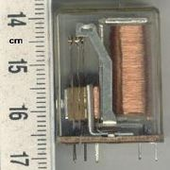

Small relay as used in electronics
A simple electromagnetic relay, such as the one taken from a car in the first picture, is an adaptation of an electromagnet. It consists of a coil of wire surrounding a soft iron core, an iron yoke, which provides a low reluctance path for magnetic flux, a movable iron armature, and a set, or sets, of contacts; two in the relay pictured. The armature is hinged to the yoke and mechanically linked to a moving contact or contacts. It is held in place by a spring so that when the relay is de-energized there is an air gap in the magnetic circuit. In this condition, one of the two sets of contacts in the relay pictured is closed, and the other set is open. Other relays may have more or fewer sets of contacts depending on their function. The relay in the picture also has a wire connecting the armature to the yoke. This ensures continuity of the circuit between the moving contacts on the armature, and the circuit track on the printed circuit board (PCB) via the yoke, which is soldered to the PCB.
When an electric current is passed through the coil, the resulting magnetic field attracts the armature and the consequent movement of the movable contact or contacts either makes or breaks a connection with a fixed contact. If the set of contacts was closed when the relay was De-energized, then the movement opens the contacts and breaks the connection, and vice versa if the contacts were open. When the current to the coil is switched off, the armature is returned by a force, approximately half as strong as the magnetic force, to its relaxed position. Usually this force is provided by a spring, but gravity is also used commonly in industrial motor starters. Most relays are manufactured to operate quickly. In a low voltage application, this is to reduce noise. In a high voltage or high current application, this is to reduce arcing.
If the coil is energized with DC, a diode is frequently installed across the coil, to dissipate the energy from the collapsing magnetic field at deactivation, which would otherwise generate a voltage spike dangerous to circuit components. Some automotive relays already include a diode inside the relay case. Alternatively a contact protection network, consisting of a capacitor and resistor in series, may absorb the surge. If the coil is designed to be energized with AC, a small copper ring can be crimped to the end of the solenoid. This "shading ring" creates a small out-of-phase current, which increases the minimum pull on the armature during the AC cycle.
By analogy with the functions of the original electromagnetic device, a solid-state relay is made with a thyristor or other solid-state switching device. To achieve electrical isolation an opt coupler can be used which is a light-emitting diode (LED) coupled with a photo transistor.
Advantages of relays:
- Relays can switch AC and DC, transistors can only switch DC.
- Relays can switch high voltages, transistors cannot.
- Relays are a better choice for switching large currents (> 5A).
- Relays can switch many contacts at once.
Disadvantages of relays:
- Relays are bulkier than transistors for switching small currents.
- Relays cannot switch rapidly (except reed relays), transistors can switch many times per second.
- Relays use more power due to the current flowing through their coil.
- Relays require more current than many ICs can provide, so a low power transistor may be needed to switch the current for the relay's coil.

CHAPTER 4: SOFTWARE DESCRIPTION

This project is implemented using following software’s:
- Express PCB – for designing circuit
- Arduino compiler - for compilation part
- Proteus 7 (Embedded C) – for simulation part
4.1 Express PCB:
Breadboards are great for prototyping equipment as it allows great flexibility to modify a design when needed; however the final product of a project, ideally should have a neat PCB, few cables, and survive a shake test. Not only is a proper PCB neater but it is also more durable as there are no cables which can yank loose.
Express PCB is a software tool to design PCBs specifically for manufacture by the company Express PCB (no other PCB maker accepts Express PCB files). It is very easy to use, but it does have several limitations.

It can be likened to more of a toy then a professional CAD program.
It has a poor part library (which we can work around)
It cannot import or export files in different formats
It cannot be used to make prepare boards for DIY production
Express PCB has been used to design many PCBs (some layered and with surface-mount parts. Print out PCB patterns and use the toner transfer method with an Etch Resistant Pen to make boards. However, Express PCB does not have a nice print layout. Here is the procedure to design in Express PCB and clean up the patterns so they print nicely.
4.1.1 Preparing Express PCB for First Use:
Express PCB comes with a less then exciting list of parts. So before any project is started head over to Audio logic and grab the additional parts by morsel, ppl, and tangent, and extract them into your Express PCB directory. At this point start the program and get ready to setup the workspace to suit your style.
Click View -> Options. In this menu, setup the units for “mm” or “in” depending on how you think, and click “see through the top copper layer” at the bottom. The standard color scheme of red and green is generally used but it is not as pleasing as red and blue.
4.1.2 The Interface:
When a project is first started you will be greeted with a yellow outline. This yellow outline is the dimension of the PCB. Typically after positioning of parts and traces, move them to their final position and then crop the PCB to the correct size. However, in designing a board with a certain size constraint, crop the PCB to the correct size before starting.
Fig: 4.1 show the toolbar in which the each button has the following functions:
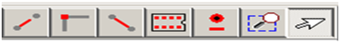
Fig 4.1: Tool bar necessary for the interface
- The select tool: It is fairly obvious what this does. It allows you to move and manipulate parts. When this tool is selected the top toolbar will show buttons to move traces to the top / bottom copper layer, and rotate buttons.
- The zoom to selection tool: does just that.
- The place pad: button allows you to place small soldier pads which are useful for board connections or if a part is not in the part library but the part dimensions are available. When this tool is selected the top toolbar will give you a large selection of round holes, square holes and surface mount pads.
- The place component: tool allows you to select a component from the top toolbar and then by clicking in the workspace places that component in the orientation chosen using the buttons next to the component list. The components can always be rotated afterwards with the select tool if the orientation is wrong.
- The place trace: tool allows you to place a solid trace on the board of varying thicknesses. The top toolbar allows you to select the top or bottom layer to place the trace on.
- The Insert Corner in trace: button does exactly what it says. When this tool is selected, clicking on a trace will insert a corner which can be moved to route around components and other traces.
- The remove a trace button is not very important since the delete key will achieve the same result.
4.1.3 Design Considerations:
Before starting a project there are several ways to design a PCB and one must be chosen to suit the project’s needs.
Single sided, or double sided?
When making a PCB you have the option of making a single sided board, or a double sided board. Single sided boards are cheaper to produce and easier to etch, but much harder to design for large projects. If a lot of parts are being used in a small space it may be difficult to make a single sided board without jumpering over traces with a cable. While there’s technically nothing wrong with this, it should be avoided if the signal travelling over the traces is sensitive (e.g. audio signals).
A double sided board is more expensive to produce professionally, more difficult to etch on a DIY board, but makes the layout of components a lot smaller and easier. It should be noted that if a trace is running on the top layer, check with the components to make sure you can get to its pins with a soldering iron. Large capacitors, relays, and similar parts which don’t have axial leads can NOT have traces on top unless boards are plated professionally.
Ground-plane or other special purposes for one side?
When using a double sided board you must consider which traces should be on what side of the board. Generally, put power traces on the top of the board, jumping only to the bottom if a part cannot be soldiered onto the top plane (like a relay), and vice- versa.
Some projects like power supplies or amps can benefit from having a solid plane to use for ground. In power supplies this can reduce noise, and in amps it minimizes the distance between parts and their ground connections, and keeps the ground signal as simple as possible. However, care must be taken with stubborn chips such as the TPA6120 amplifier from TI. The TPA6120 datasheet specifies not to run a ground plane under the pins or signal traces of this chip as the capacitance generated could affect performance negatively.
4.2 Arduino Compiler:

For ATmega328 microcontroller, Aurduino compiler is used for compilation. The compilation steps are as follows:
- Open Aurduino C compiler.
- You will be prompted to choose a name for the new project, so create a separate folder where all the files of your project will be stored, choose a name and click save.
Installing the Drivers for the Arduino Uno (from Arduino.cc)
- Plug in your board and wait for Windows to begin it’s driver installation process
- After a few moments, the process will fail, despite its best efforts
- Click on the Start Menu, and open up the Control Panel
- While in the Control Panel, navigate to System and Security. Next, click on System
- Once the System window is up, open the Device Manager
- Look under Ports (COM & LPT). You should see an open port named “Arduino UNO (COMxx)”. If there is no COM & LPT section, look under ‘Other Devices’ for ‘Unknown Device’
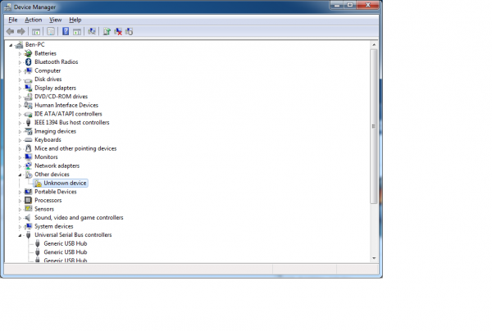
- Right click on the “Arduino UNO (COMxx)” or “Unknown Device” port and choose the “Update Driver Software” option
- Next, choose the “Browse my computer for Driver software” option
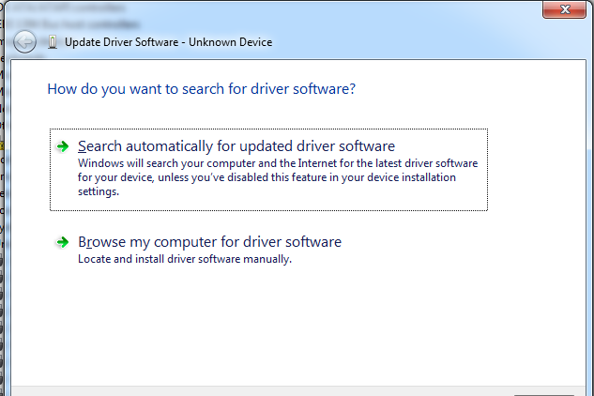
- Finally, navigate to and select the Uno’s driver file, named “ArduinoUNO.inf”, located in the “Drivers” folder of the Arduino Software download (not the “FTDI USB Drivers” sub-directory). If you cannot see the .inf file, it is probably just hidden. You can select the ‘drivers’ folder with the ‘search sub-folders’ option selected instead.
- Windows will finish up the driver installation from there
For earlier versions of the Arduino boards (e.g.Arduino Duemilanove, Nano, or Diecimila) check out this page for specific directions.

Launch and Blink!
After following the appropriate steps for your software install, we are now ready to test your first program with your Arduino board!
- Launch the Arduino application
- If you disconnected your board, plug it back in
- Open the Blink example sketch by going to: File > Examples > 1.Basics > Blink
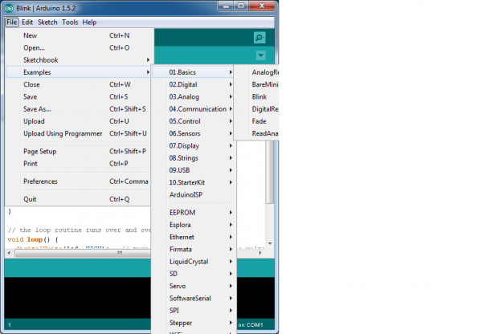
- Select the type of Arduino board you’re using: Tools > Board > your board type
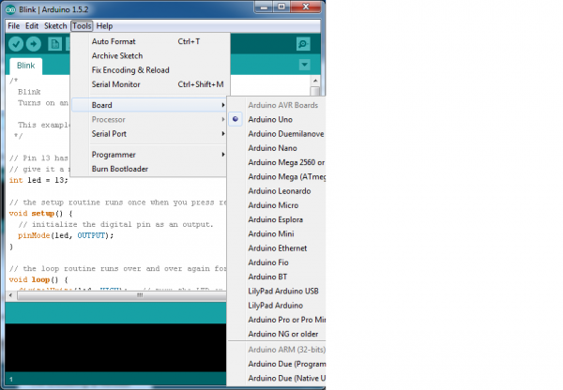
- Select the serial/COM port that your Arduino is attached to: Tools > Port > COMxx
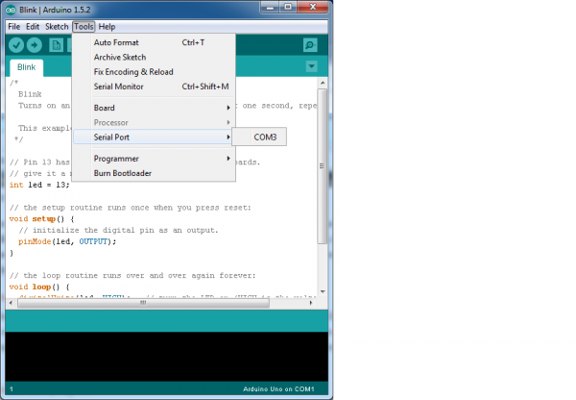
- If you’re not sure which serial device is your Arduino, take a look at the available ports, then unplug your Arduino and look again. The one that disappeared is your Arduino.
- With your Arduino board connected, and the Blink sketch open, press the ‘Upload’ button.
4.3 Proteus:
Proteus is software which accepts only hex files. Once the machine code is converted into hex code, that hex code has to be dumped into the microcontroller and this is done by the Proteus. Proteus is a programmer which itself contains a microcontroller in it other than the one which is to be programmed. This microcontroller has a program in it written in such a way that it accepts the hex file from the pic compiler and dumps this hex file into the microcontroller which is to be programmed. As the Proteus programmer requires power supply to be operated, this power supply is given from the power supply circuit designed and connected to the microcontroller in proteus. The program which is to be dumped in to the microcontroller is edited in proteus and is compiled and executed to check any errors and hence after the successful compilation of the program the program is dumped in to the microcontroller using a dumper.

CHAPTER 5: PROJECT DESCRIPTION
In this chapter, schematic diagram and interfacing of ARDUINO microcontroller with each module is considered.
Fig: The schematic diagram of “voice controlled device using Bluetooth”
Working principle:
When 230v ac supply is converted into 5v dc supply through regulated power supply(RPS).The 5v dc supply is given to the all the components in the project . In this project we are using bluetooth module and secure it. When the Bluetooth module is placed the will sense it and send the data, then the gate is opened with the help of dc motor and sound we can from buzzer.

CHAPTER 6: ADVANTAGES AND DISADVANTAGES

Advantages:
- Highly efficient and user friendly design.
- Easy to operate.
- Low power consumption.
- Works anywhere in the world using Bluetooth technology.
- Automatic and secured access control system

Disadvantages:
- Interfacing Bluetooth module with microcontroller is highly sensitive.

Applications:
• This system can be practically implemented in real time at places where security is a concern.
Trees can be prevented by getting robbed.
• In case anybody tries to cut the tree the location will be tracked and information will be sent to control room immediately.
• Since all the trees are connected to sensors individual attention is given on all the trees.
• Sensors work accurately so it is easier to install and operate with good results.
• Data base of all the trees can be maintained

CHAPTER 7: RESULTS

7.1 Conclusion:
Integrating features of all the hardware components used have been developed in it. Presence of every module has been reasoned out and placed carefully, thus contributing to the best working of the unit. Secondly, using highly advanced IC’s with the help of growing technology, the project has been successfully implemented. Thus the project has been successfully designed and tested.
7.3 Future Scope:
Our project “VOICE CONTROLLED DEVICE USING BLUETOOTH”is mainly intended to design a security control system using Bluetooth module. The system consists of a Bluetooth module interfacing to Micro Controller.

When bluetooth is placed in front of Bluetooth which reads the tag number and this is fed as input to the micro controller. The micro controller is programmed in such a way that the input from is checked and displays the respective information on the LCD display and then the toll gate accessing can using DC motor. The microcontroller takes the responsibility to even alert through buzzer alarm system when wrong tag has been detected. We can use here ZIGBEE also to got more faster operation.

REFERENCES
The sites which were used while doing this project:
1. www.wikipedia.com
2. www.allaboutcircuits.com
3. www.microchip.com
4. www.howstuffworks.com

Books referred:

- Raj kamal –Microcontrollers Architecture, Programming, Interfacing and System Design.
- Mazidi and Mazidi –Embedded Systems.
- PCB Design Tutorial –David.L.Jones.
- ARDUINO Microcontroller Manual – Microchip.
- Embedded C –Michael.J.Pont.

